

**CERTIFICATE**

This is to certify that the project report entitled **“Old Age Home Management System”** submitted by **“Miss Sakunde Aarti Sanjay”** MCA I Exam Seat No: **“ ”** In partial fulfillment of the award of **Master of Computer Application (M.CA.)** course submitted to Shivaji University, Kolhapur for the year 2022-2023

and this is a genuine and benefited work prepared under my supervision and guidance.

To the best of knowledge and belief, the matter presented in this project report has been submitted earlier to any university for similar purpose.

**Place:** Satara Date:

Project Guide Examiner HOD of MCA



**CERTIFICATE**

This is to certify that the project report entitled **“Old Age Home Management System”** submitted by **“Miss Sakunde Sakshi Shivaji”** MCA I Exam Seat No: **“ ”** In partial fulfillment of the award of **Master of Computer Application (M.CA.)** course submitted to Shivaji University, Kolhapur for the year 2022-2023

and this is a genuine and benefited workprepared under my supervision and guidance.

To the best of knowledge and belief, the matter presented in this project report has been submitted earlier to any university for similar purpose.

**Place:** Satara Date:

Project Guide Examiner HOD of MCA

**CERTIFICATE**

This is to certify that the project report entitled **“Old Age Home Management System”** submitted by **“Miss Nikam Sejal Vikas”** MCA I Exam Seat No: **“ ”**

In partial fulfillment of the award of **Master of Computer Application (M.CA.)**

course submitted to Shivaji University, Kolhapur for the year 2022-2023

and this is a genuine and benefited work prepared under my supervision and guidance.

To the best of knowledge and belief, the matter presented in this project report has been submitted earlier to any university for similar purpose.

**Place:** Satara Date:

Project Guide Examiner HOD of MCA



# **DECLARATION**

**To,**

The Hod,

YSPM’s YTC, Satara.

**Respected Sir/Madam,**

We undersigned hereby declare that the project entitled **“Old Age Home Management System”** with reference to **“Yashoda Technical Campus, Satara”** developed under the guidance of **Prof. Snehal Jadhav** is our original work. The information generated in this project work is based on the data collected by us.

We have not copied from any other project report submitted to Shivaji University, Kolhapur earlier.

**Place:** Satara.

**Date:**

**Miss Sakunde Aarti Sanjay**

# **DECLARATION**

**To,**

The Hod,

YSPM’s YTC, Satara.

**Respected Sir/Madam,**

We undersigned hereby declare that the project entitled **“Old Age Home Management System”** with reference to **“Yashoda Technical Campus, Satara”** developed under the guidance of **Prof. Snehal Jadhav** is our original work. The information generated in this project work is based on the data collected by us.

We have not copied from any other project report submitted to Shivaji University, Kolhapur earlier.

**Place:** Satara.

**Date:**

**Miss Sakunde Sakshi Shivaji**



# **DECLARATION**

**To,**

The Hod,

YSPM’s YTC, Satara.

**Respected Sir/Madam,**

We undersigned hereby declare that the project entitled **“Old Age Home Management System”** with reference to **“Yashoda Technical Campus, Satara”** developed under the guidance of **Prof. Snehal Jadhav** is our original work. The information generated in this project work is based on the data collected by us.

We have not copied from any other project report submitted to Shivaji University, Kolhapur earlier.

**Place:** Satara.

**Date:**

**Miss Nikam Sejal Vikas**



We express our sincere gratitude to my guide **Prof. Snehal Jadhav** for her/hisvaluable guidance and help during the course .Without her advice and co- operation I would not have succeeded in my endeavor. Her thoughtfulness and understanding was vast and thoroughly helpful in successful completion of the project.

We are thankful to Hod of MCA Department. for making available all there quired resources and very valued constructive criticism that has driven to complete the project successfully.

We are especially thankful to those who helped me directly-indirectly incompletion of this work successfully.

Place: Satara Date:

**Miss Sakunde Aarti Sanjay**



We express our sincere gratitude to my guide **Prof. Snehal Jadhav** for her/hisvaluable guidance and help during the course .Without her advice and co- operation I would not have succeeded in my endeavor. Her thoughtfulness and understanding was vast and thoroughly helpful in successful completion of the project.

We are thankful to Hod of MCA Department. for making available all therequired resources and very valued constructive criticism that has driven to complete the project successfully.

We are especially thankful to those who helped me directly-indirectly incompletion of this work successfully.

Place: Satara Date:

**Miss Sakunde Sakshi Shivaji**



We express our sincere gratitude to my guide **Prof. Snehal Jadhav** for her/hisvaluable guidance and help during the course .Without her advice and co- operation I would not have succeeded in my endeavor. Her thoughtfulness and understanding was vast and thoroughly helpful in successful completion of the project.

We are thankful to Hod of MCA Department. for making available all therequired resources and very valued constructive criticism that has driven to complete the project successfully.

We are especially thankful to those who helped me directly-indirectly incompletion of this work successfully.

Place: Satara Date:

**Miss Nikam Sejal Vikas**

## Index

|  |  |  |
| --- | --- | --- |
| **Sr no** | **Content** | **Page no** |
| **1** | **CHAPTER 1: INTRODUCTION**  Introduction | **14-20** |
| 1.1 Existing System |
| 1.2 Proposed system |
|  |
|  |
| **2** | **CHAPTER 2: PROPOSED SYSTEM**  2.1 Front End | **21-22** |
| 2.2 Back End |
| 2.3 Software Specification |
| **3** | **CHAPTER 3: SYSTEM ANALYSIS**   * 1. Data Flow Diagram (DFD)   2. First level (DFD)   3. Second level (DFD)   4. Entity Relationship Diagram (ERD)   5. Use Case Diagram   6. Activity Diagram   7. Sequence Diagram | **23-42** |
| **4** | **CHAPTER 4: SYSTEM DESIGN**  4.1 Database Design  4.2 User Manual  4.3 Input and Output screens with data | **43-44** |
| **5** | **CHAPTER 5: ANNEXURE**  5.1 Source code | **45** |
| **6** | **CHAPTER 6: CONCLUSION AND SUGGESTIONS**  6.1 Limitations  6.2 Further Enhancement  6.3 Conclusion | **46** |
| **7** | **REFERENCES** | **46** |
|  |  |  |

# **Introduction:-**

The last century has witnesses a rapid increase in the population of the elderly people in developed and industrialized countries. This phenomenon is not restricted to the western world only, but many countries such as ours are now feeling the impact of this transaction. This situation leads the uncared of elder people which require extra care and which can be fulfilled by good environment. So, this web application provide interaction between elderly people and good home shelter (old age home).

“Old Age Home System” is web application which provide the end-to-end smart web application for the old age people and old age home. This application is helpful for old age home for keeping records of senior citizen who live in the old age home. Each elderly people assign a registration number through which person detail find so easily.

* 1. **Existing System:-**
     + Reports are prepared manually as and when needed maintaining of report is very tedious task.
     + In the existing system dealing with for searching senior citizens history is the time consuming.
     + In this existing system user cannot login and registration in this system.
     + If user want to admit in this old age home then they can be admitted by admin.
     + Any internet user can use this existing website to search for any kind of old age home related information.

## **Proposed System:-**

* The proposed system has better capability of each the user activities while interacting with the system.
* The search of the citizens is much faster than present system. Hence it cause to saving time for the further work.
* The system is completely online and saves the data of the citizens in the database reducing the manual work and provides greater data security.
* Feedback feature is included which helps in keeping attention on users’ needs and requirements. The user can have user friendliness with the system by allowing him to leave his response, advice or opinion about this system.



# **Front End:-**

**APACHE**

The Apache HTTP Server Project is an effort to develop and maintain an open-source HTTP server for modern operating systems including UNIX and Windows. The goal of this project is to provide a secure, efficient and extensible server that provides HTTP services in sync with the current HTTP standards.

The Apache HTTP Server ("http") was launched in 1995 and it has been the most popular web server on the Internet since April 1996. It has celebrated its 20th birthday as a project in February 2015.

**PHP**

* PHP stands for PHP: Hypertext Preprocessor.
* PHP is a server-side scripting language, like ASP.
* PHP scripts are executed on the server.
* PHP supports many databases (MYSQL, Informix, Oracle, Sybase, Solid, Generic ODBC, etc.).
* PHP is an open source software.
* PHP is free to download and use

**HTML:**

Hyper Text Markup Language is the computer language that facilitates website creation. The language, which has code words and syntax just like any other language, is relatively easy to comprehend and, as time goes on, increasingly powerful in what it allows someone to create. HTML continues to evolve to meet the demands and requirements of the Internet under the guise of the World Wide Web Consortium, the organization that designs and maintains the language; for instance, with the transition to Web 2.0.

Hyper Text is the method by which Internet users navigate the web. By clicking on special text called hyperlinks, users are brought to new pages. The use of hyper means it is not linear, so users can go anywhere on the Internet simply by clicking on the available links. Markup is what HTML tags do to the text inside of them; they mark it as a specific type of text. For example, markup text could come in the form of boldface or italicized type to draw specific attention to a word or phrase.

**CSS:**

**Cascading Style Sheets** (**CSS**) is a stylesheet language used to describe the presentation of a document written in HTML or XML (including XML dialects such as SVG, MathML or XHTML). CSS describes how elements should be rendered on screen, on paper, in speech, or on other media.

CSS is among the core languages of the **open web** and is standardized across Web browsers according to W3C specifications. Previously, the development of various parts of CSS specification was done synchronously, which allowed the versioning of the latest recommendations. You might have heard about CSS1, CSS2.1, or even CSS3. There will never be a CSS3 or a CSS4; rather, everything is now CSS without a version number.



**JAVASCRIPT:**

**JavaScript** (often shortened to **JS**) is a lightweight, interpreted, object-oriented language with first-class functions, and is best known as the scripting language for Web pages, but it's used in many non-browser environments as well. It is a prototype-based, multi-paradigm scripting language that is dynamic, and supports object-oriented, imperative, and functional programming styles.

JavaScript is a cross-platform, object-oriented scripting language used to make webpages interactive (e.g., having complex animations, clickable buttons, popup menus, etc.). There are also more advanced server side versions of JavaScript such as Node.js, which allow you to add more functionality to a website than downloading files (such as real time collaboration between multiple computers). Inside a host environment (for example, a web browser), JavaScript can be connected to the objects of its environment to provide programmatic control over them.



# **Back End:-**

## Introduction to SQL Server:-

SQL server is a free and easy to use database product. It is designed to provide a database platform that offers superior ease of use, enabling fast deployments for its target scenarios. Features like auto close & the ability to copy database as file which are enabled by default in SQL server , while the high availability & business intelligence features are absent . It is very easy to “scale up”. SQL server was developed with two distinct uses in mind. The first is as server product , especially as a web server or database server . Second is as local client data store where the application data access does not depends on the network. Ease of use and simplicity are the key goals.

The two main usage scenarios of SQL server are:

* + - Hobbyist building client/server application.
    - Non-professional developers building web applications.
* Security

For SQL server, one of the goals is to provide secure defaults for the different components. For instance, the networking protocols such as TCP/IP and Named Pipes are turned off. SQL browser service is not started unless the user explicitly asks for this in the setup command line

.The SA or system admin account is disabled by default if Windows Authentication is used. Normal users on the machine have almost no privileges on the SQL server instance. A local Administrator on the server must explicitly grant relevant permissions for normal users so that they can use SQL functionality



* Attach ‘DB’ Filename

You can specify a relative or absolute file path for the Attach DB File Name connection string entry. The specified database file is attached when the connection is opened and this database is used as the default database for that connection . If the database is already attached when Attach DB File Name is invoked, then attach does nothing. This keyword supports a special string called |Data Directory| that points at runtime to the data directory of the application where database files are stored . This special string should be at beginning of the file path, works only against a local file system, and checks are done for Syntax so that the file path is not higher than the directory pointed to by the substitution string.

* Auto-Close

This feature releases the file locks on the user database when there are no active connections to it. Thus, the database is ready to moved or copied after the application that uses it is closed.

## Feature Description

* Online Restore

With SQL server 2005, database administrators are able to platform a restore operation while an instance of SQL Server is running. Online restore improves the availability of SQL Server because only the data being restored is unavailable; the rest of the database remains online and available.

* Online Indexing Operations

The online index option allows concurrent modifications (updates, deletes , and inserts) to the underlying table or clustered index data and any associated indexes during index data definition language(DDL) execution.



For example , while a clustered index is being rebuilt, you can continue to make updates to the underlying data and perform query against the data.

* Fast Recovery

A new faster recovery option improves availability of SQL Server databases. Administrators can reconnect to a recovering database after transaction log has been rolled forward.

* SQL Server Management Studio

SQL Server 2005 includes SQL Server Management Studio, a new integrated suite of management tools with the functionality to develop, deploy and troubleshoot SQL Server database, as well as enhancements to previous functionality.

* Dedicated Administrator Connection

SQL Server 2005 provides a dedicated administrator connection that administrators can use to access a running server even if the server is locked or otherwise unavailability . This capability enables administrators to troubleshoot problems on a server by executing diagnostic functions or Transact-SQL statements.

* Hosted Common Language Runtime

WithSQL Server 2005 developers can create database object using familiar languages such as Microsoft Visual C#.NET and Microsoft ASP.NET. Developers can also create two new objects –user-defined types and aggregates.

* Native XML Support

Native XML data can stored, queried, and indexed in SQL Server database - allowing developers to build new classes of connected applications around Web services and across any platform or device.



* Security Enhancement

The security model in SQL Server 2005 separates users from objects , provides fine-grain access , and enables greater control of data access. Additionally, all system tables are implemented as views, providing more control over database system objects.

* Web Services

With SQL Server 2005 developers can develop Web services in the database tier, making SQL Server a hypertext transfer protocols (HTTP) listener and providing a new type of data access capabilities for Web services access capability for Web service – centric applications.

## Fact Finding Techniques (methods):-

Gathering facts is not virtual, it should be done with diligence.

Information gathering and complex organization is not an easy task. It has to be in an organized way.

1. No system details are left out.
2. Right problems are identified and repetitive problems are avoided.
3. Wrong or incomplete details are not collected. Fact finding techniques that are commonly used. They are:-

## Existing system document review:-

Record and Document Searching.



## Interviewing:-

The method is used to collect the information. It gives quantitative information about problems. Failures, objectives, constraints.

## Record Viewing:-

This method is used to establish the information. It includes different types of files maintained for everyday collection of information.

## Project Planning:-

We were suggested by our guide to choose a The Old Age Home System is developed to automate storing of details of old people with the help of modern technology.

Without an Old Age Home System managing and maintaining the details of old people is a tedious job for any old age home. Old Age Home System will store all the details of old people and also this project is developed as a web application and it will work over web.

The purpose of developing “Old Age Home System” is to computerized the traditional way of recording data of old people in old age home and to generate the report automatically.

They were helping us to design our website more efficiently and neatly we first classified all information regarding to old people services according to their categories then we referred to the similar e- commerce websites to get the ideas for designing so we could improve our work. We distributed equal work to each of our team member

## Hardware & Software Requirement:-

EXPECTED HARDWARE REQUIREMENT FOR WEBSITE DEPLOYING

**Hardware Configuration:**

**Client Side:**

|  |  |
| --- | --- |
| **RAM** | 512 MB |
| **Hard disk** | 10 GB |
| **Processor** | 1.0 GHz |

**Server side:**

|  |  |
| --- | --- |
| **RAM** | 1 GB |
| **Hard disk** | 20 GB |
| **Processor** | 2.0 GHz |

**Software Requirement:**

**Client Side:**

|  |  |
| --- | --- |
| **Web Browser** | Google Chrome or any compatible browser |
| **Operating System** | Windows or any equivalent OS |

**Server Side:**

|  |  |
| --- | --- |
| **Web Server** | APACHE |
| **Server side Language** | PHP5.6 or above version |
| **Database Server** | MYSQL |
| **Web Browser** | Google Chrome or any compatible browser |
| **Operating System** | Windows or any equivalent OS |

**Module Description:**

In this project we have used PHP and MySQL database. It has two modules

**admin** and **user.**

**Admin Module:**

1. **Dashboard:** In this section admin can see all detail in brief like total number of services, Total number of senior citizen , total number of unread enquiry received and total number of unread enquiry.
2. **Pages:** In this section admin can manage about us, contact us pages, rules and eligibility.
3. **Services:** In this section admin can manage services (add/update/delete).
4. **SC (Senior Citizen) Details:** In this section admin can manage the detail of senior citizen (add/update/delete) who lived in old age home.
5. **Enquiry:** In this section admin can read new enquiry (unread enquiry) and view read enquiry (read enquiry).
6. **Search:** In this section admin can search senior citizen details with the help of his/her registration number.
7. **Reports:** In this section admin can view senior citizen details in particular periods.

**User Module:**

In Old Age Home Management System user can do following activities

1. **Home Page:** User can visit the home page and view some details of rules, eligibility and about us information.
2. **Services:** User views the services which offer by old age home.
3. **Eligibility:** User views the eligibility criteria for old age home.
4. **Rules:** User views the rules for old age home.
5. **About Us:** User sees the detail of old age home.
6. **Contact Us:** User can contact with old age home.



SYSTEM ANALYSIS

Following are the different standard signs used in these diagrams and they are representing with its meaning.

Process:-

Entity :-

Database:-

Flow of Data:



## **3.1 Context Level** **DFD:**-

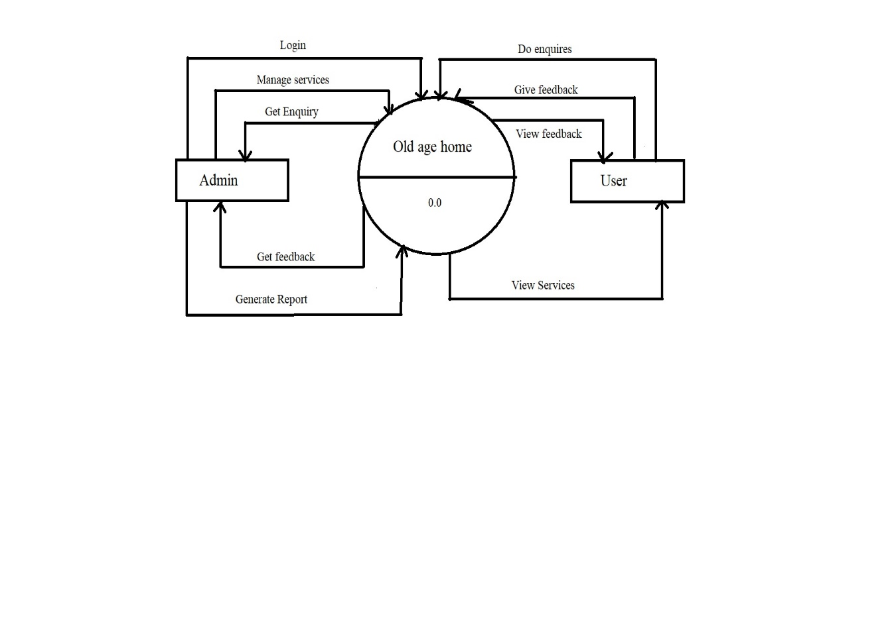



**3.2 First Level DFD for Admin:-**

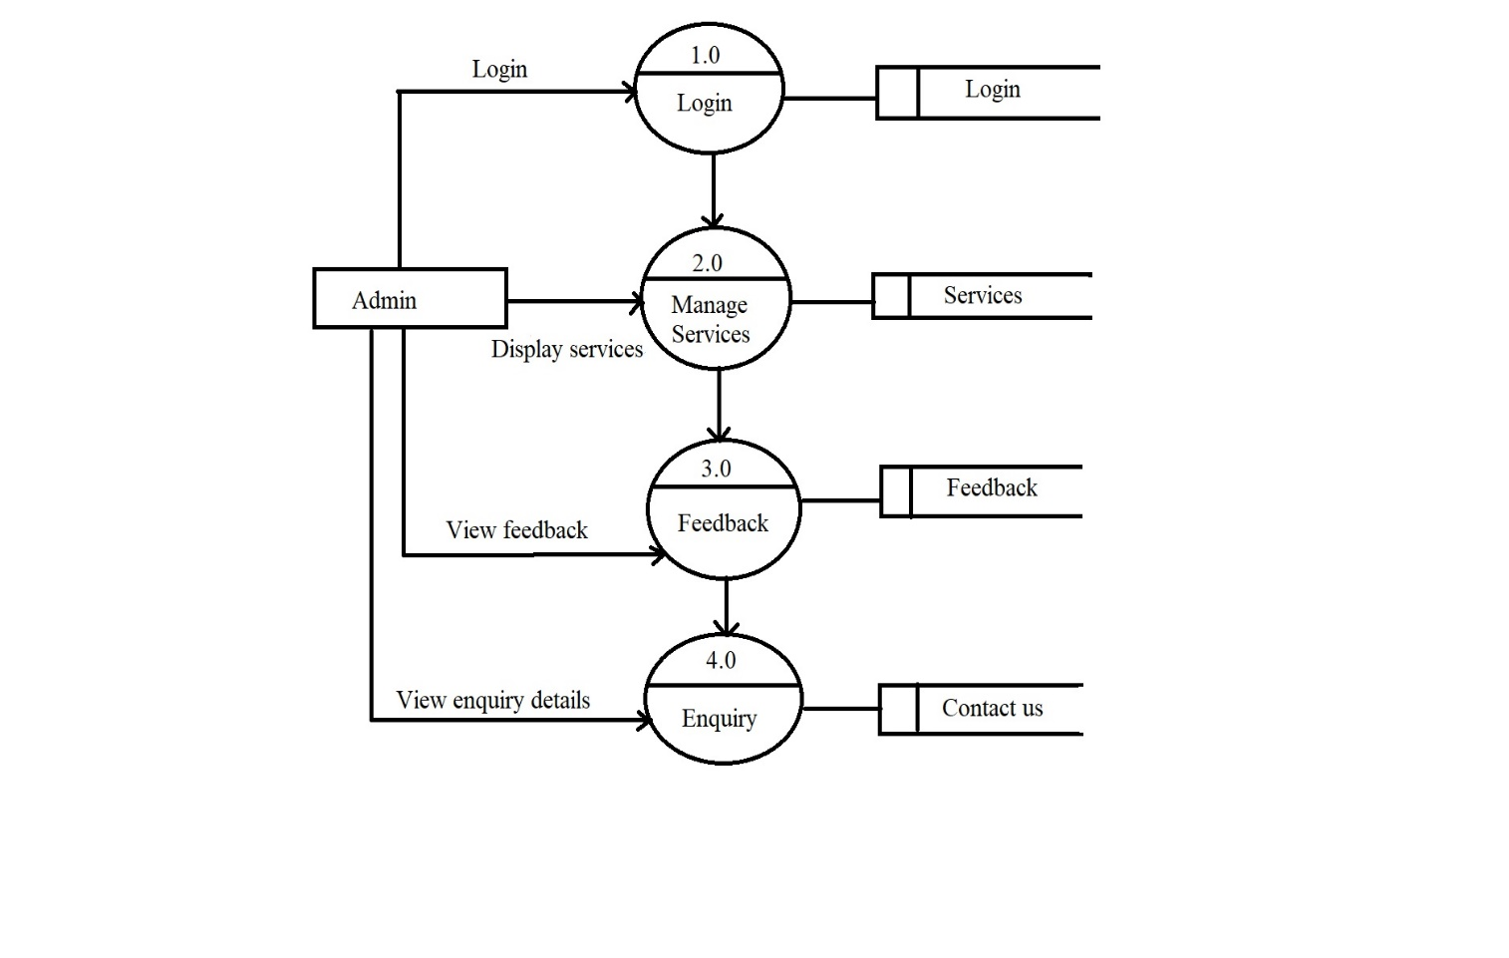

**3.3 Second Level DFD for Customer:-**

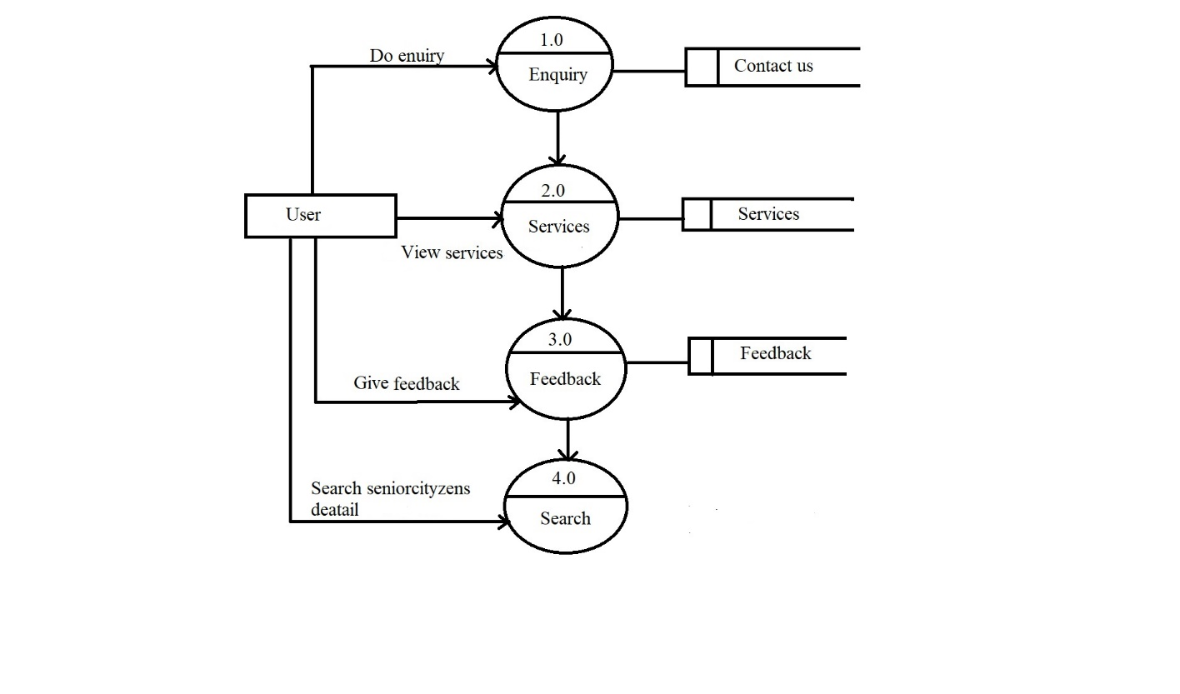



**3.4 ERD:-**

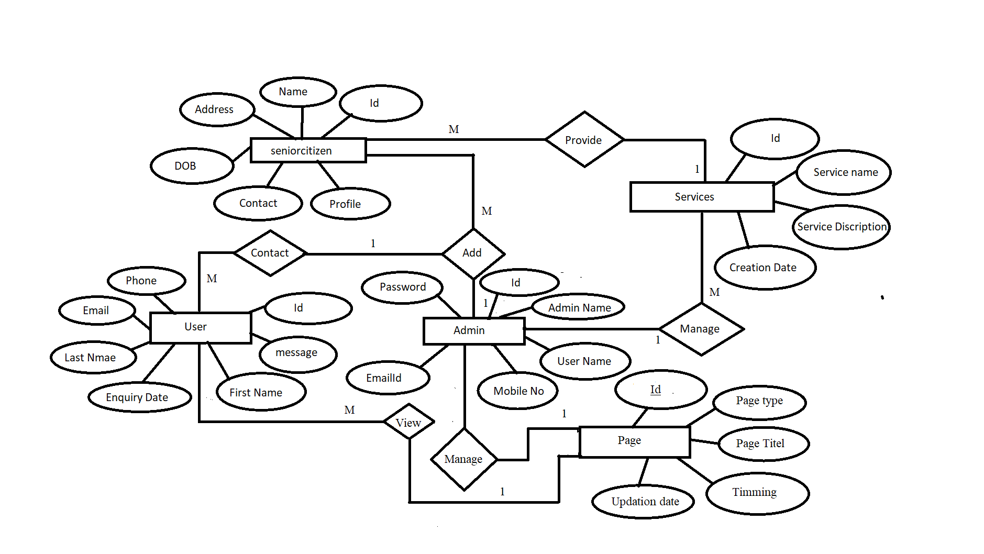



**3.5 Use Case Diagram:-**

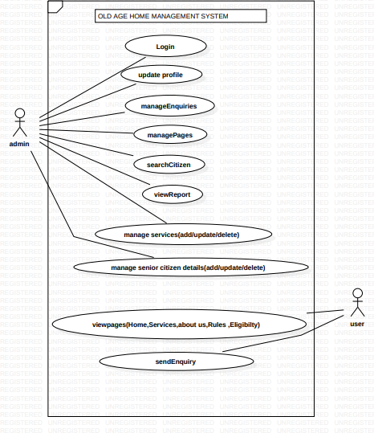



**3.6 Activity Diagram:**

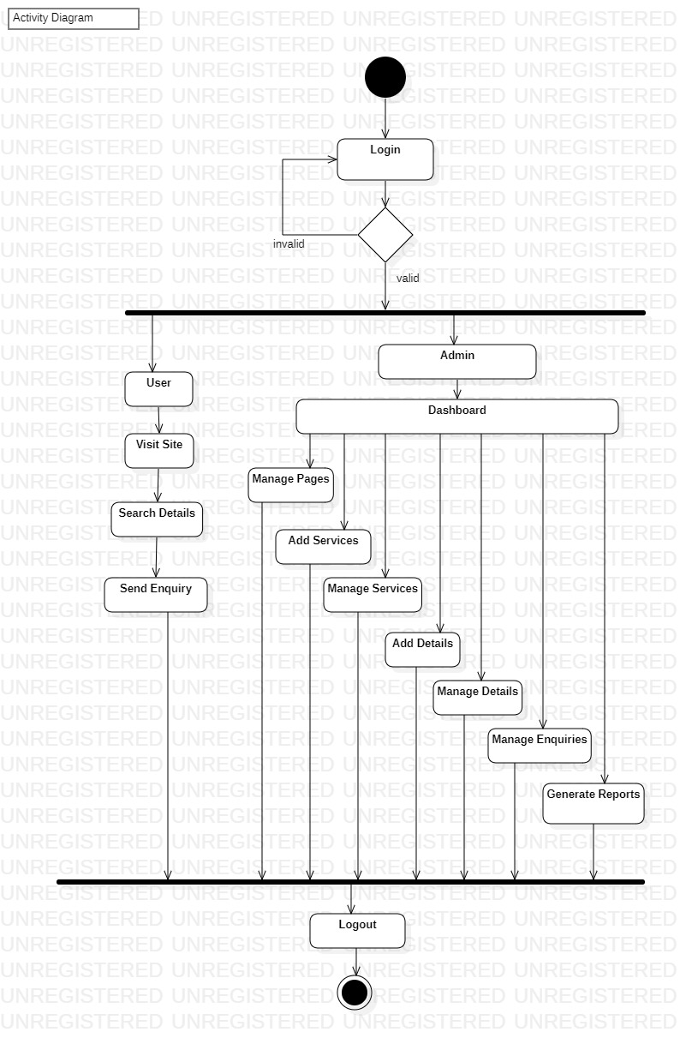

**3.7 Sequence Diagram:**

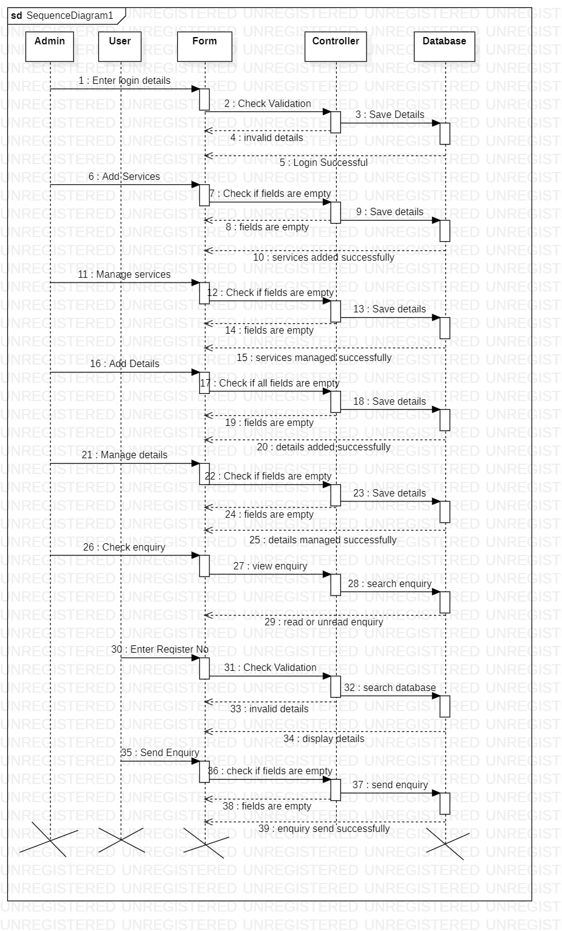

**SYSTEM DESIGN**

**Data Dictionary:**

Data Dictionaries are an integral component of analysis, since data flow diagram by him or she does not fully describe the subjects of the investigation.  A data dictionary is a catalog of the element in as system. This element centers on data and the way are structured to meet user‘s requirements and needs. The major elements are dataflow, data stores and processes. Data dictionary stores details and description of these elements. It is developed during data analysis and assists analysis involved in determining the system. Four main reasons of analysis are: To manage the details in large system. To communicate a common meaning for all system elements.  To document the features of the system. To locate the errors and omissions in the system. The data dictionary contains two types of descriptions as following:

1. Data Elements: The most fundamental data level is the data element. Data element is the building block for all others in the system.

2. Data Structure: A data structure is a set of items that are related to one another that describes components in the system.

**4.1 Database Design:**

**Table Name:** tbladmin

**Primary Key:** ID

**Description:** To store the details of the admin**.**

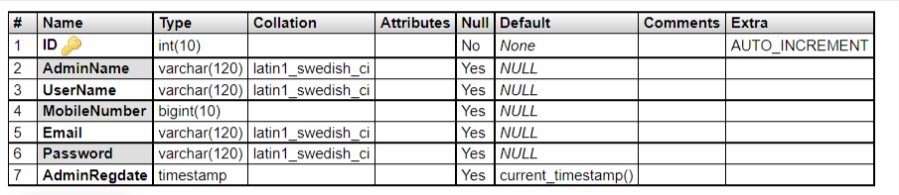

**Table Name:** tblcontact

**Primary Key:** ID

**Description:** To store the details of the user.

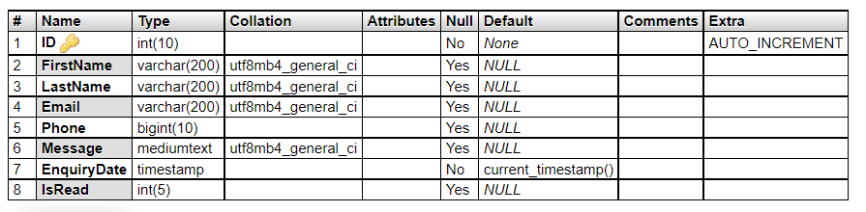

**Table Name:** tblpage

**Primary Key:** ID

**Description:** To manage the details of the pages.

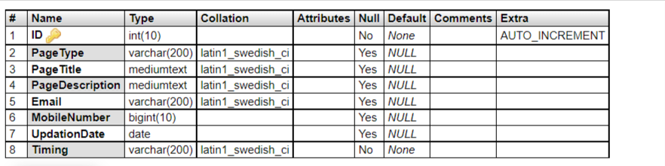

**Table Name:** tblseniorcitizen

**Primary Key:** ID

**Description:** To store the details of the senior citizens.

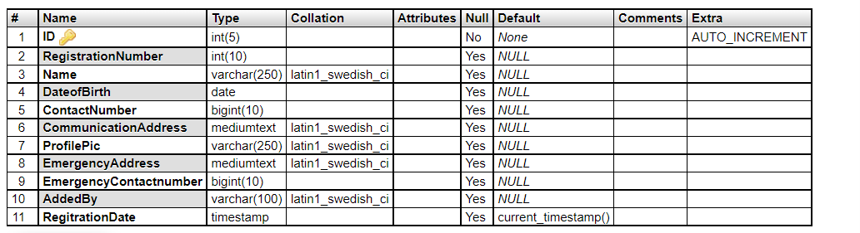

**Table Name:** tblseniorcitizen

**Primary Key:** ID

**Description:** To store the details of the services.



**User Interface Design**

The user interface is a very important part of the system. A good and user-friendly interface attracts the user toward it. Whereas a bad one makes the user experience bad and they never return to the system. As we have shown several use cases in this system have developed these interfaces to interact with the system. User can visit the home page of the system. The user can also visit the other pages like About, Services, Eligibility, Search and Contact. The pages are designed to be interactive and informative as well. The pages contains information that a user must know.

**Login Page**

Admin need to login the system using userid and password in order to access the admin panel.

**Home Page**

Home page contains a summary about all the pages available in the system.

**About us Page**

This page contains the information about the main motive behind developing this project.

**Services**

This page contains the information about various services that we provide such as Security Facility, Medical Facility etc.

**Eligibility**

This page contains the information about eligibility criteria to admit a senior citizen.

**Rules**

This page contains the rules to be followed by the visitors and what to do in case of any emergency.

**Search**

In this page a user can search about details of a senior citizen by the registration number.

**Contact**

A user can send his feedback using the contact page.

**Test Procedure and Implementation**

**Unit Testing:** This is the lowest level of testing that is conducted to remove syntax.

**Module testing:** A module is a collection of dependent components such as an object class, an abstract data type or some looser collection of procedures logic errors from a single unit. Individual components are tested to ensure that they operate correctly. Each component is tested independently, without other system components.

**System testing:** The sub-systems are integrated to make up the system. The system as a complete entity is tested over here. This process is concerned with finding errors that result from unanticipated interactions between sub-systems. It is also concerned with validating that the system meets its functional.

**Sub-System testing:** This phase involves testing collections of modules, which have been integrated into sub-systems. This tests for problems that arise from component interactions. This testing should begin as soon as usable versions of some of the system components are available. A module encapsulates related components, so can be tested without other system modules & non-functional requirements.

**Acceptance testing:** This is the final stage in the testing process before the system is accepted for operational use. The system is tested with data supplied by the system customer rather than simulated test data. Acceptance testing may reveal errors testing the emergent system properties & omissions in the system requirements definition because the real data exercise the system in different ways from the test data. It may also reveal requirements problems where the system’s facilities do not really meet the user’s needs or the system performance is unacceptable.

**USER MANUAL**

**Admin Module:**

* **Login:** Admin have to login to the system using correct userid and password.
* **Dashboard:** After successful login admin dashboard will be opened on which various details like Total services, Senior citizens, Unread Enquiry and read enquiries numbers are present.
* **Profile:** The details of the admin profile can be updated in this page.
* **Pages:** Details of the pages are managed.
* **Services:** Services can be added or managed on this page.
* **Senior Citizen Details:** Details of the senior citizen can be added or managed.
* **Enquiry:** The enquiries which are sent by the users can be read.
* **Reports:** The reports of the senior citizens are generated.
* **Search:** The details of the senior citizens can be searched using the registration number.

**4.2 Input output screens with data**

**Admin Module**

**Admin Login**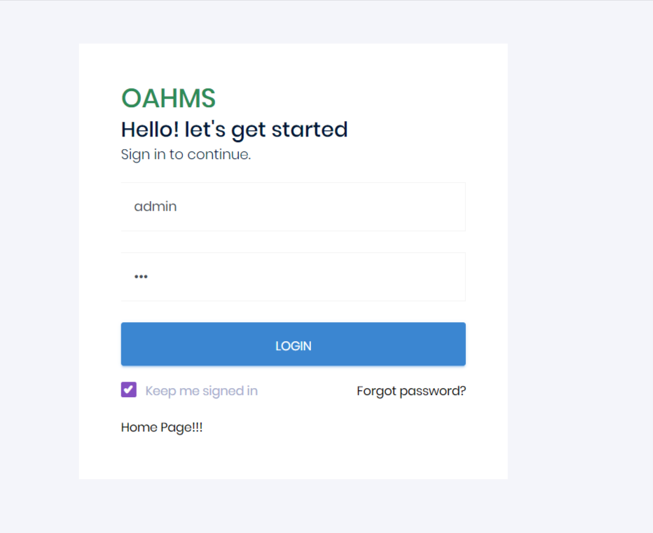

**Dashboard**

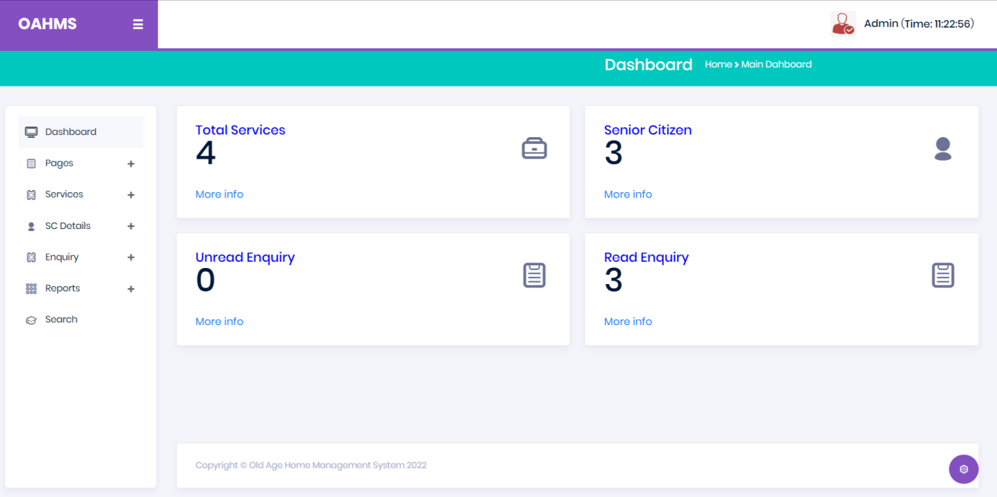

**Profile**

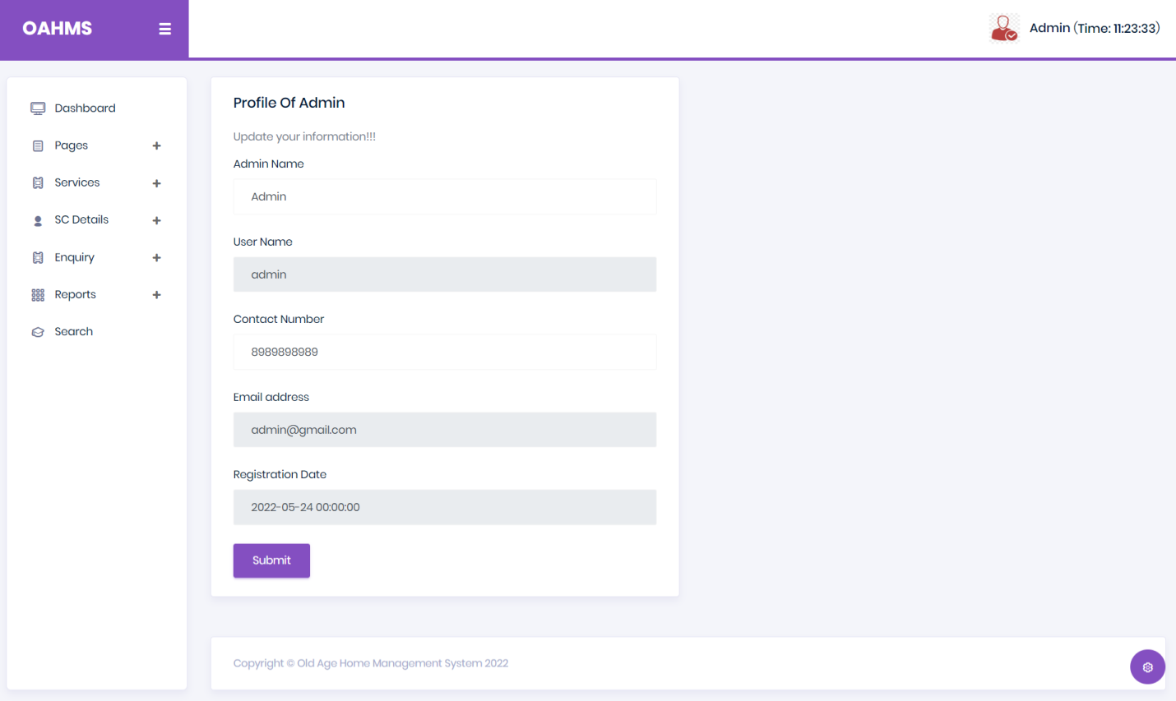

**Change Password**

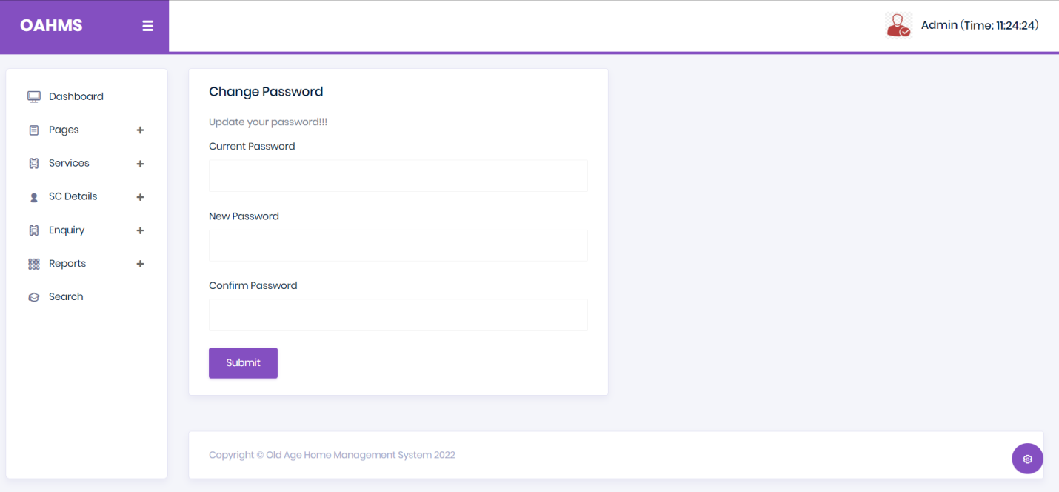

**About Us Page**

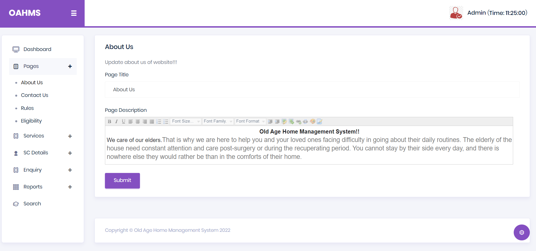

**Contact Us Page**

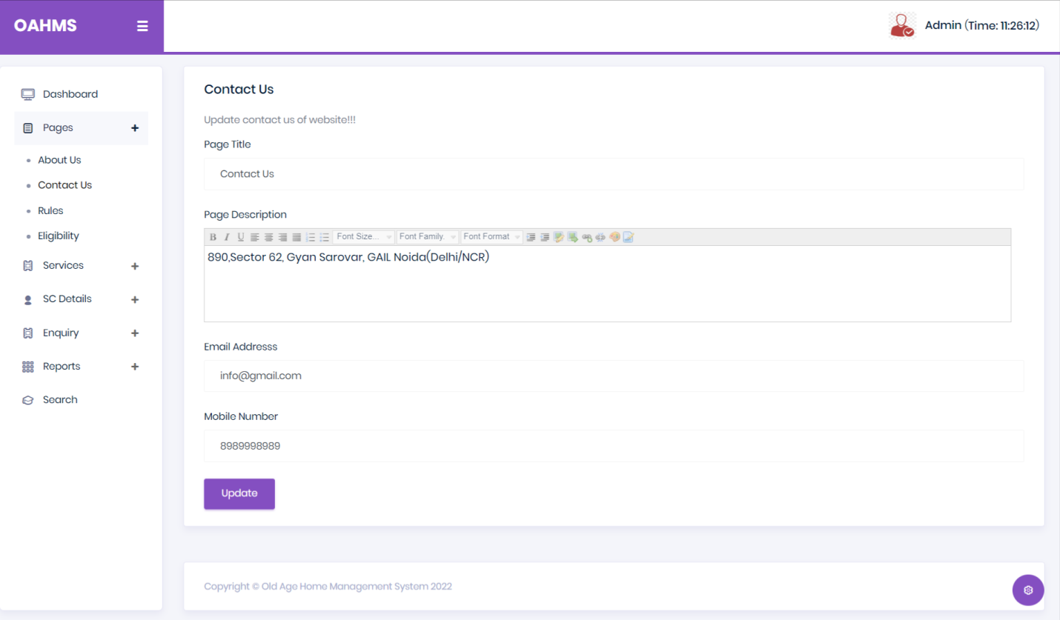

**Rules**

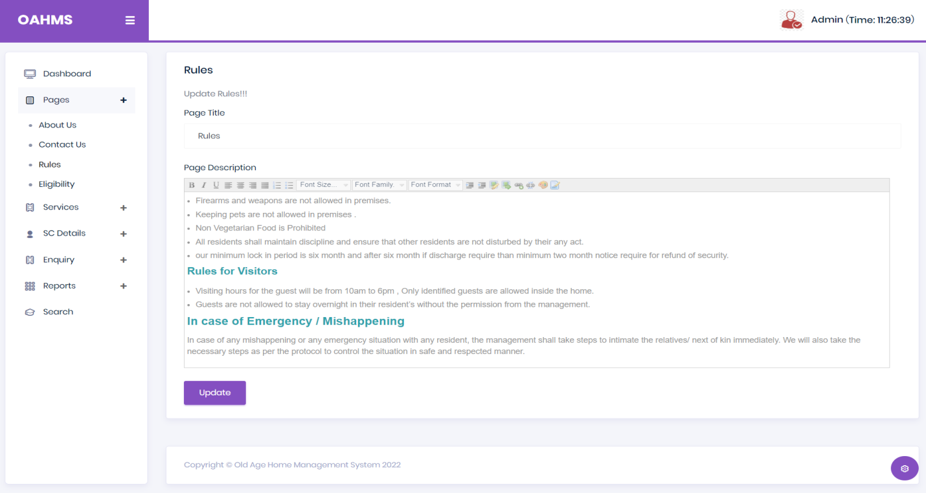

**Eligibility**

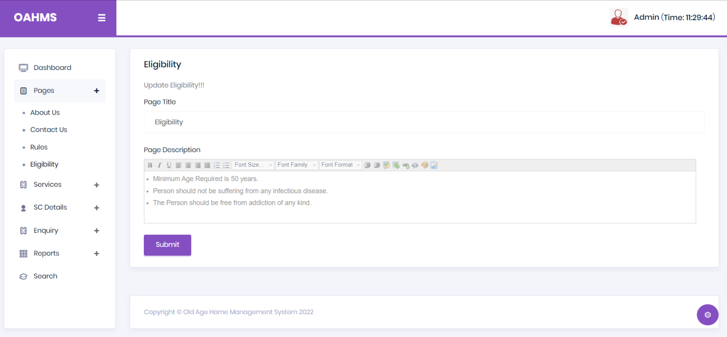

**Add Services**

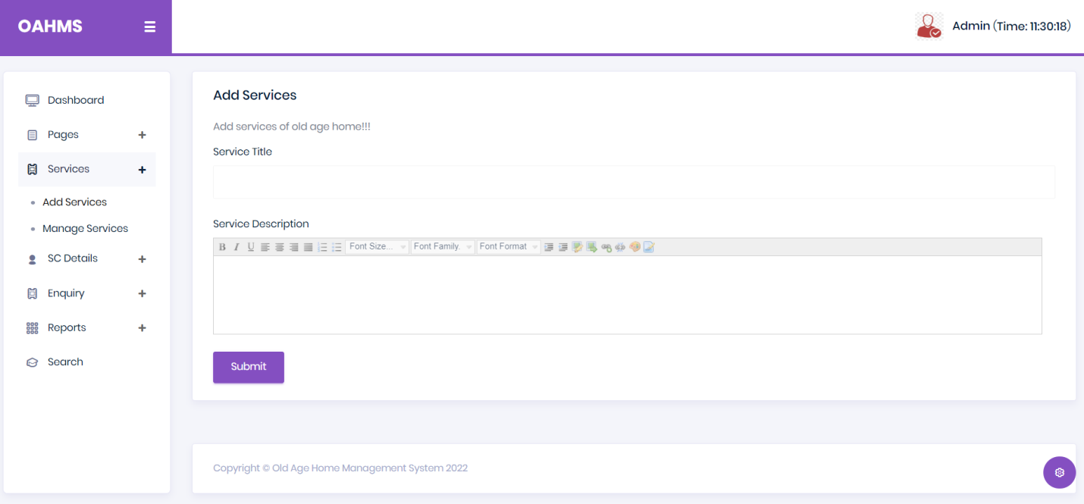

**Manage Services**

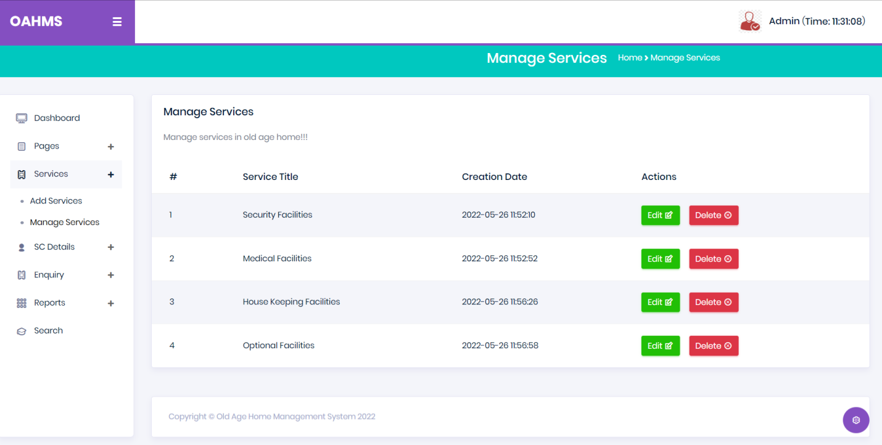

**Update Services**

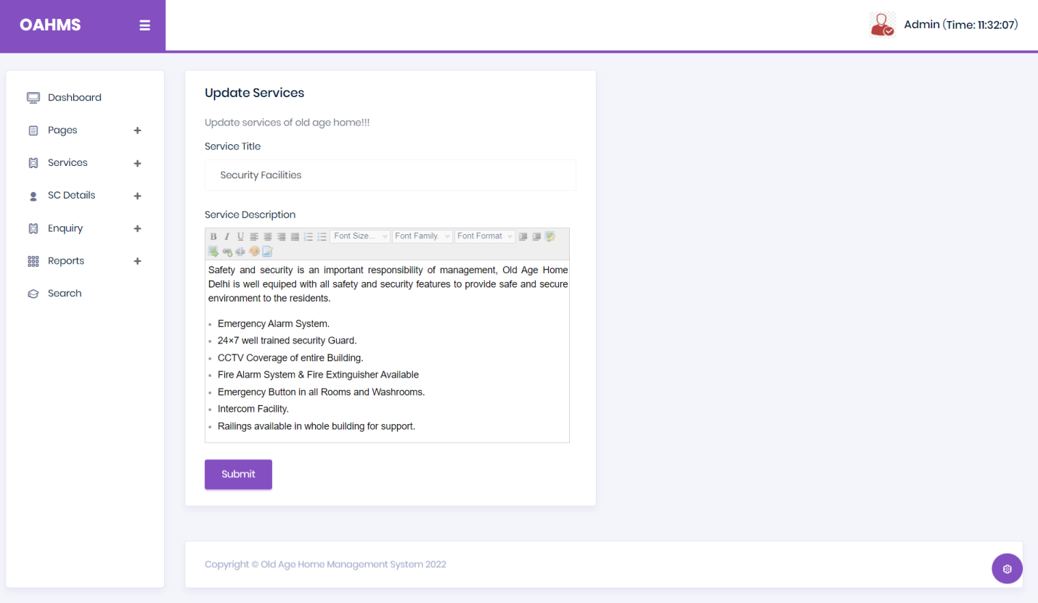

**Add Senior Citizen Details**

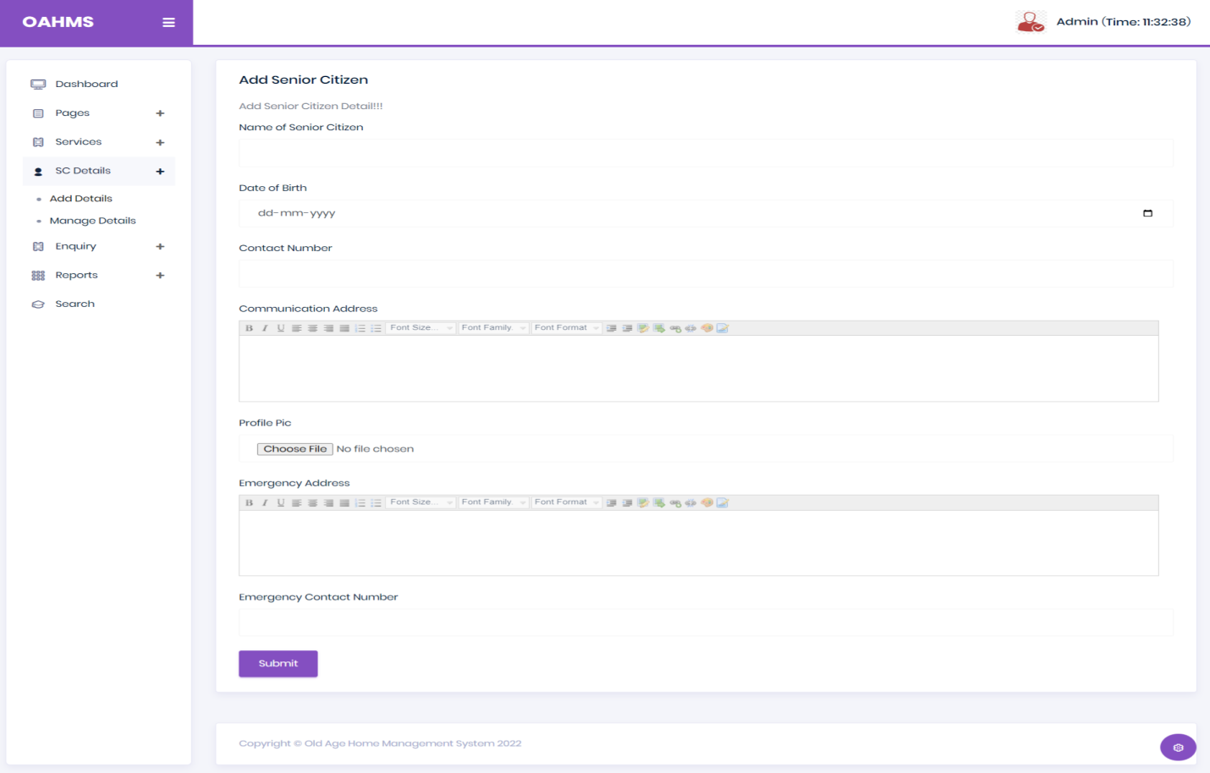

**Manage Senior Citizen Details**

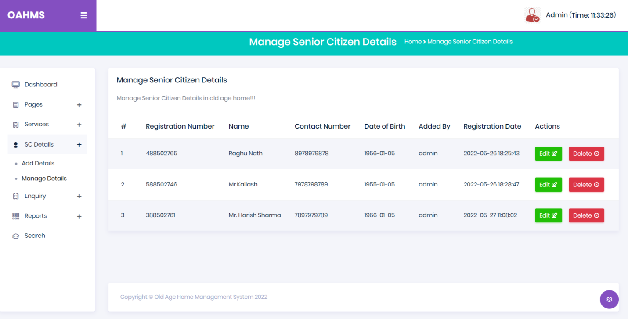

**Update Senior Citizen Details**

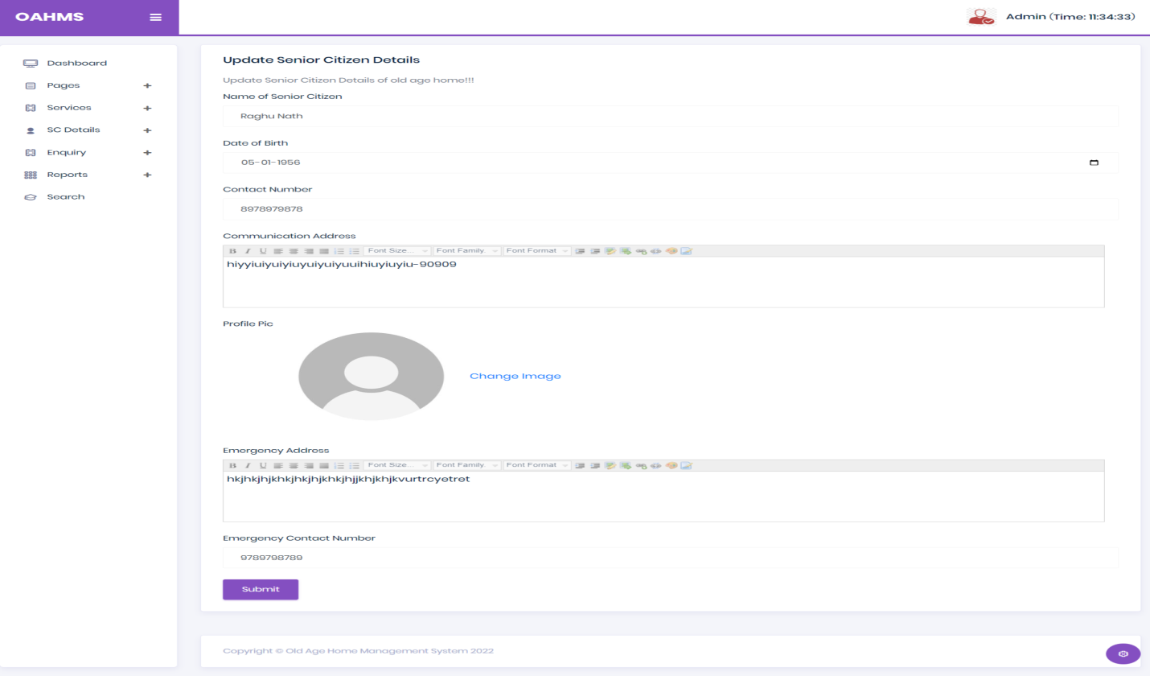

**Unread Enquiry**

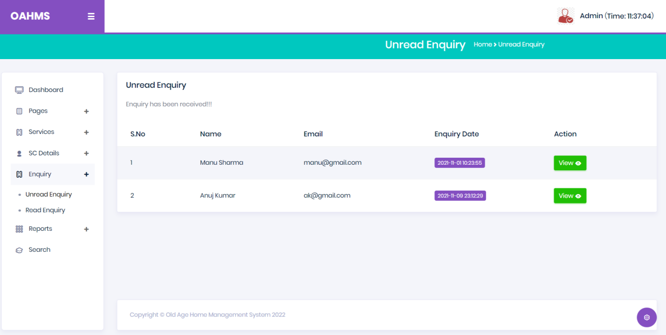

**Read Enquires**

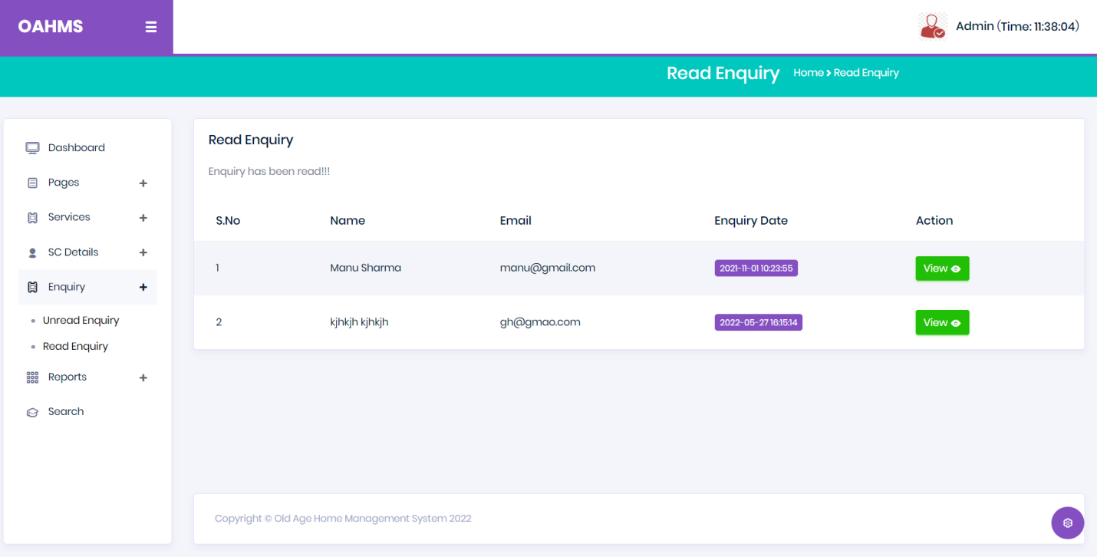

**View Enquiry**

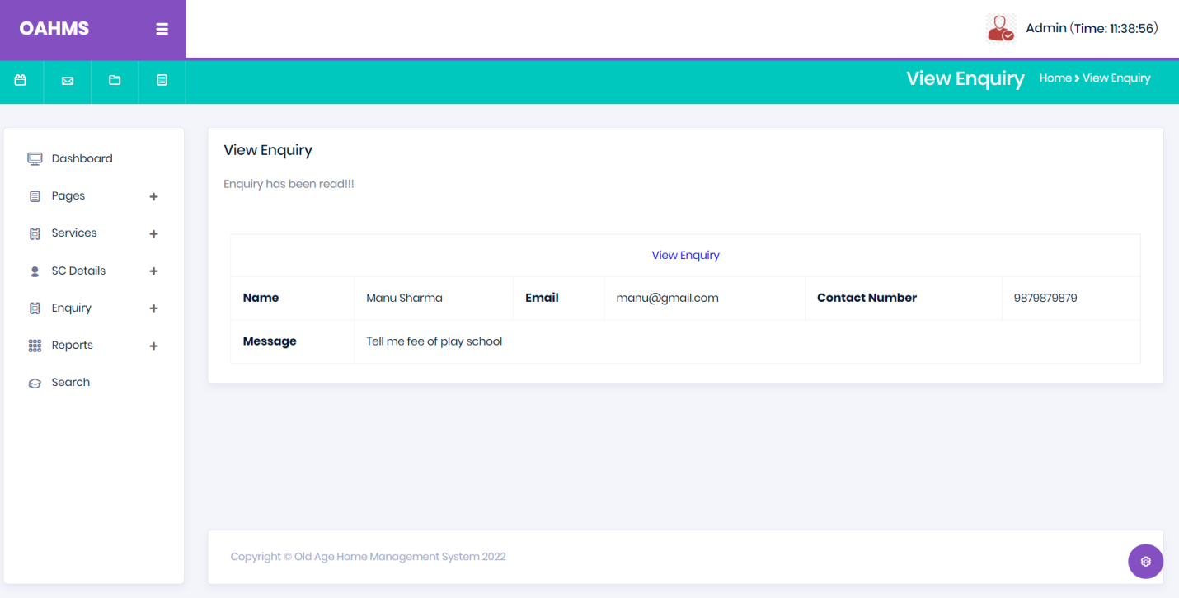

**Between Dates Report**

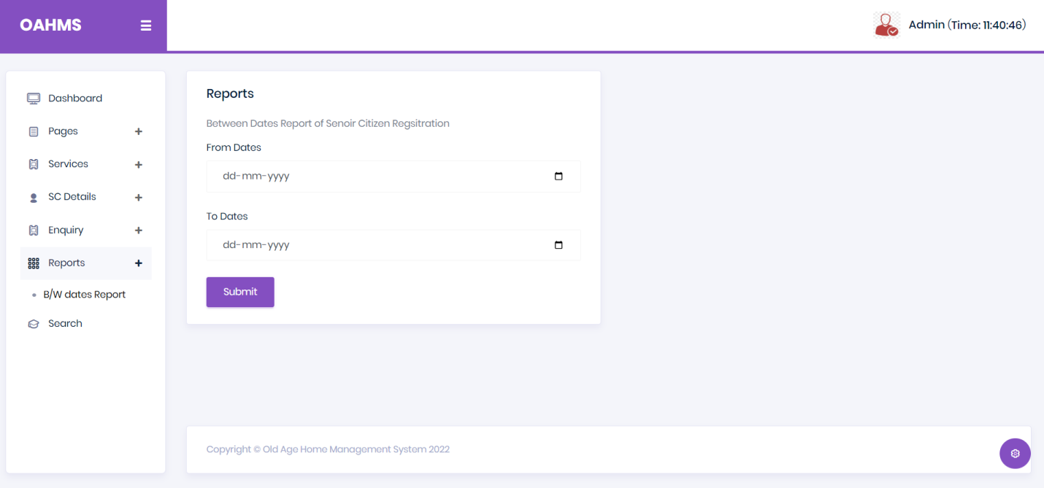

**Between Dates Report Details**

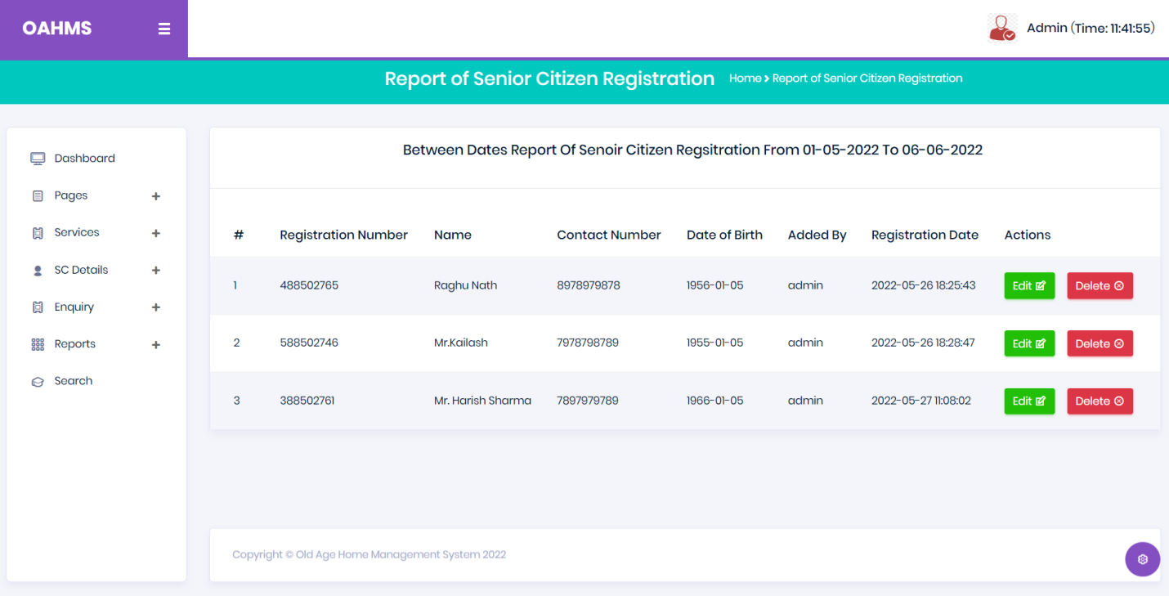

**Search**

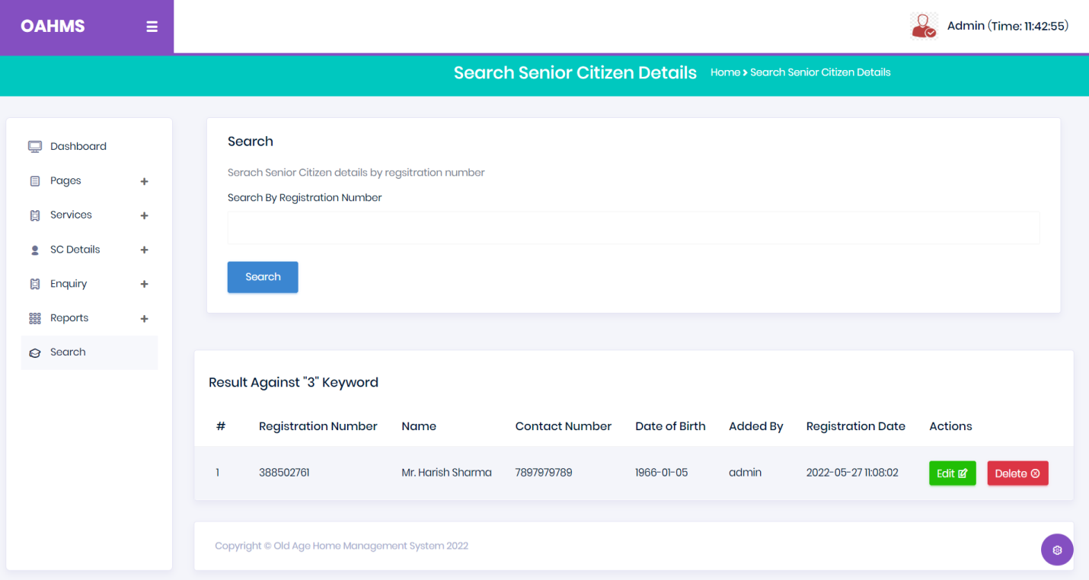

**Forgot Password**

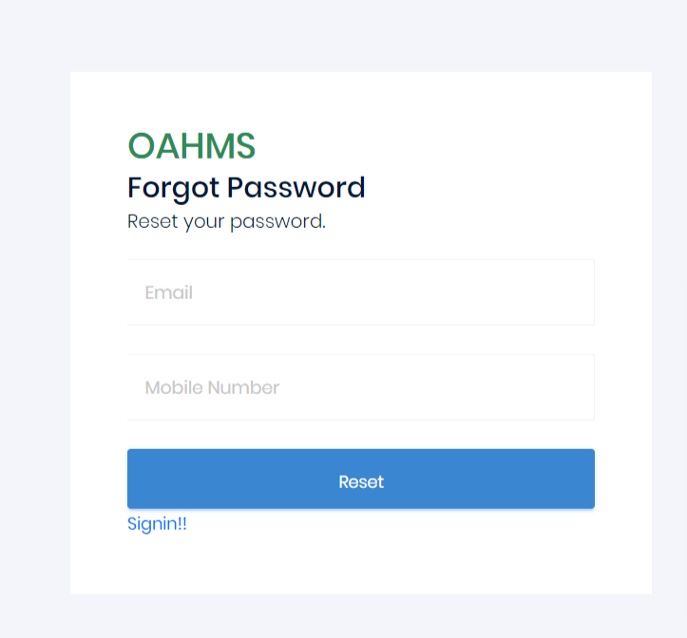

**Reset Password**

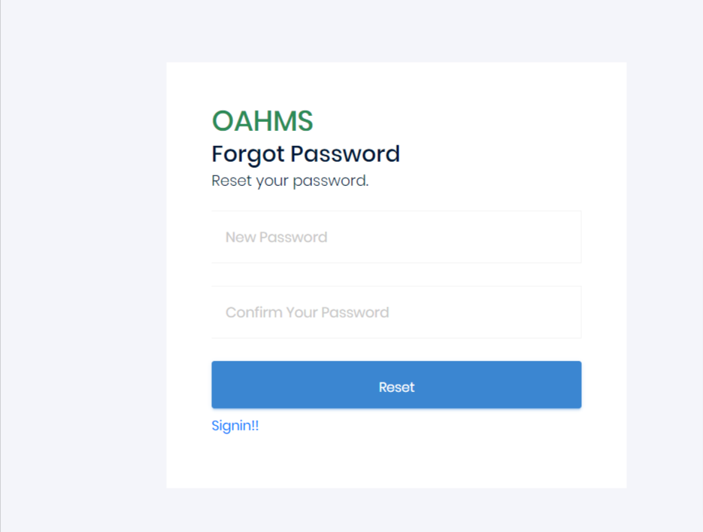

**User Module**

**Home Page**

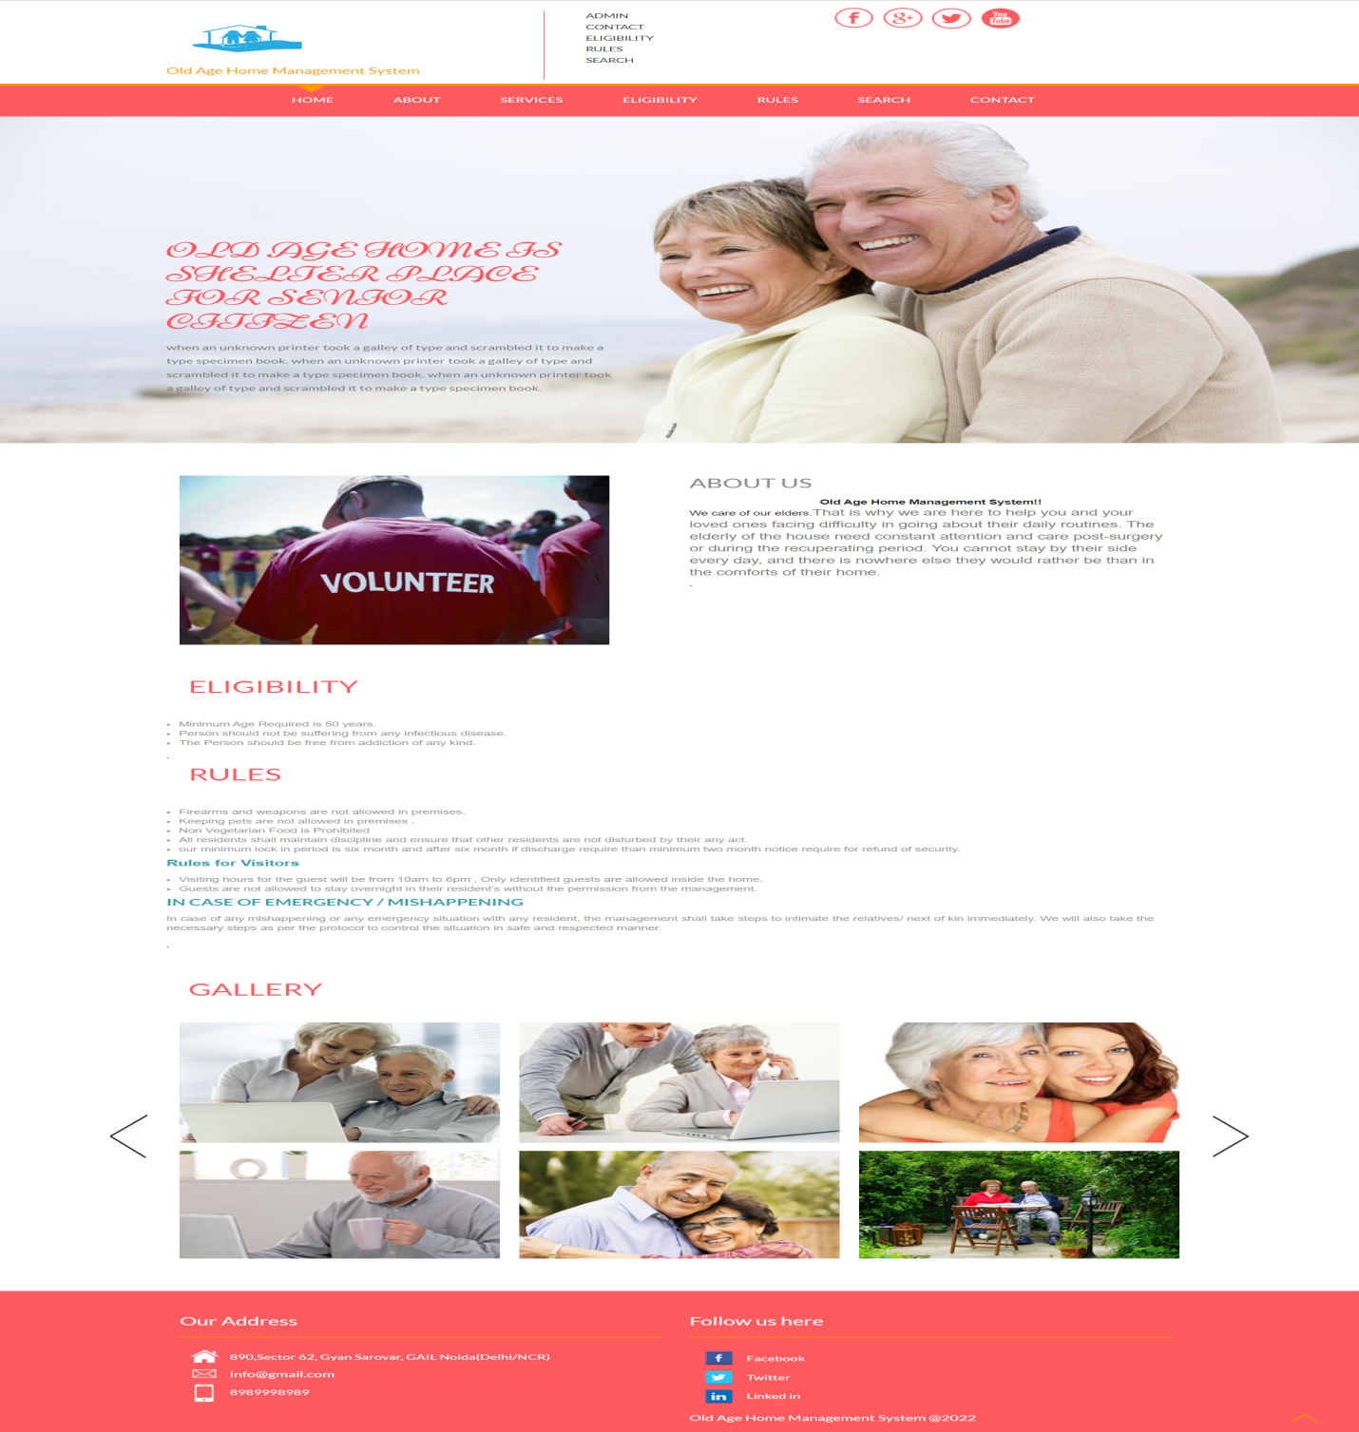

**About Us**

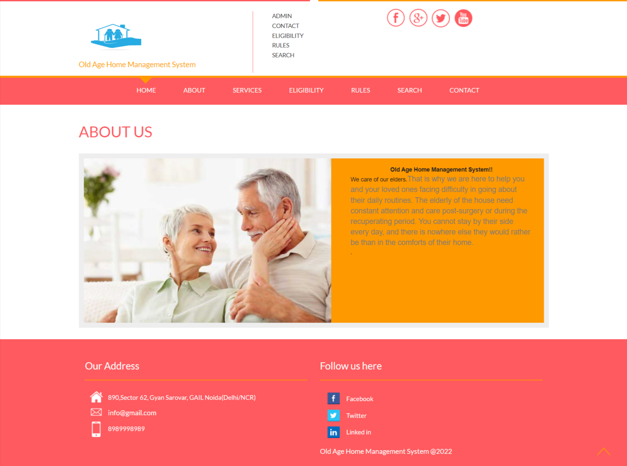

**Services**

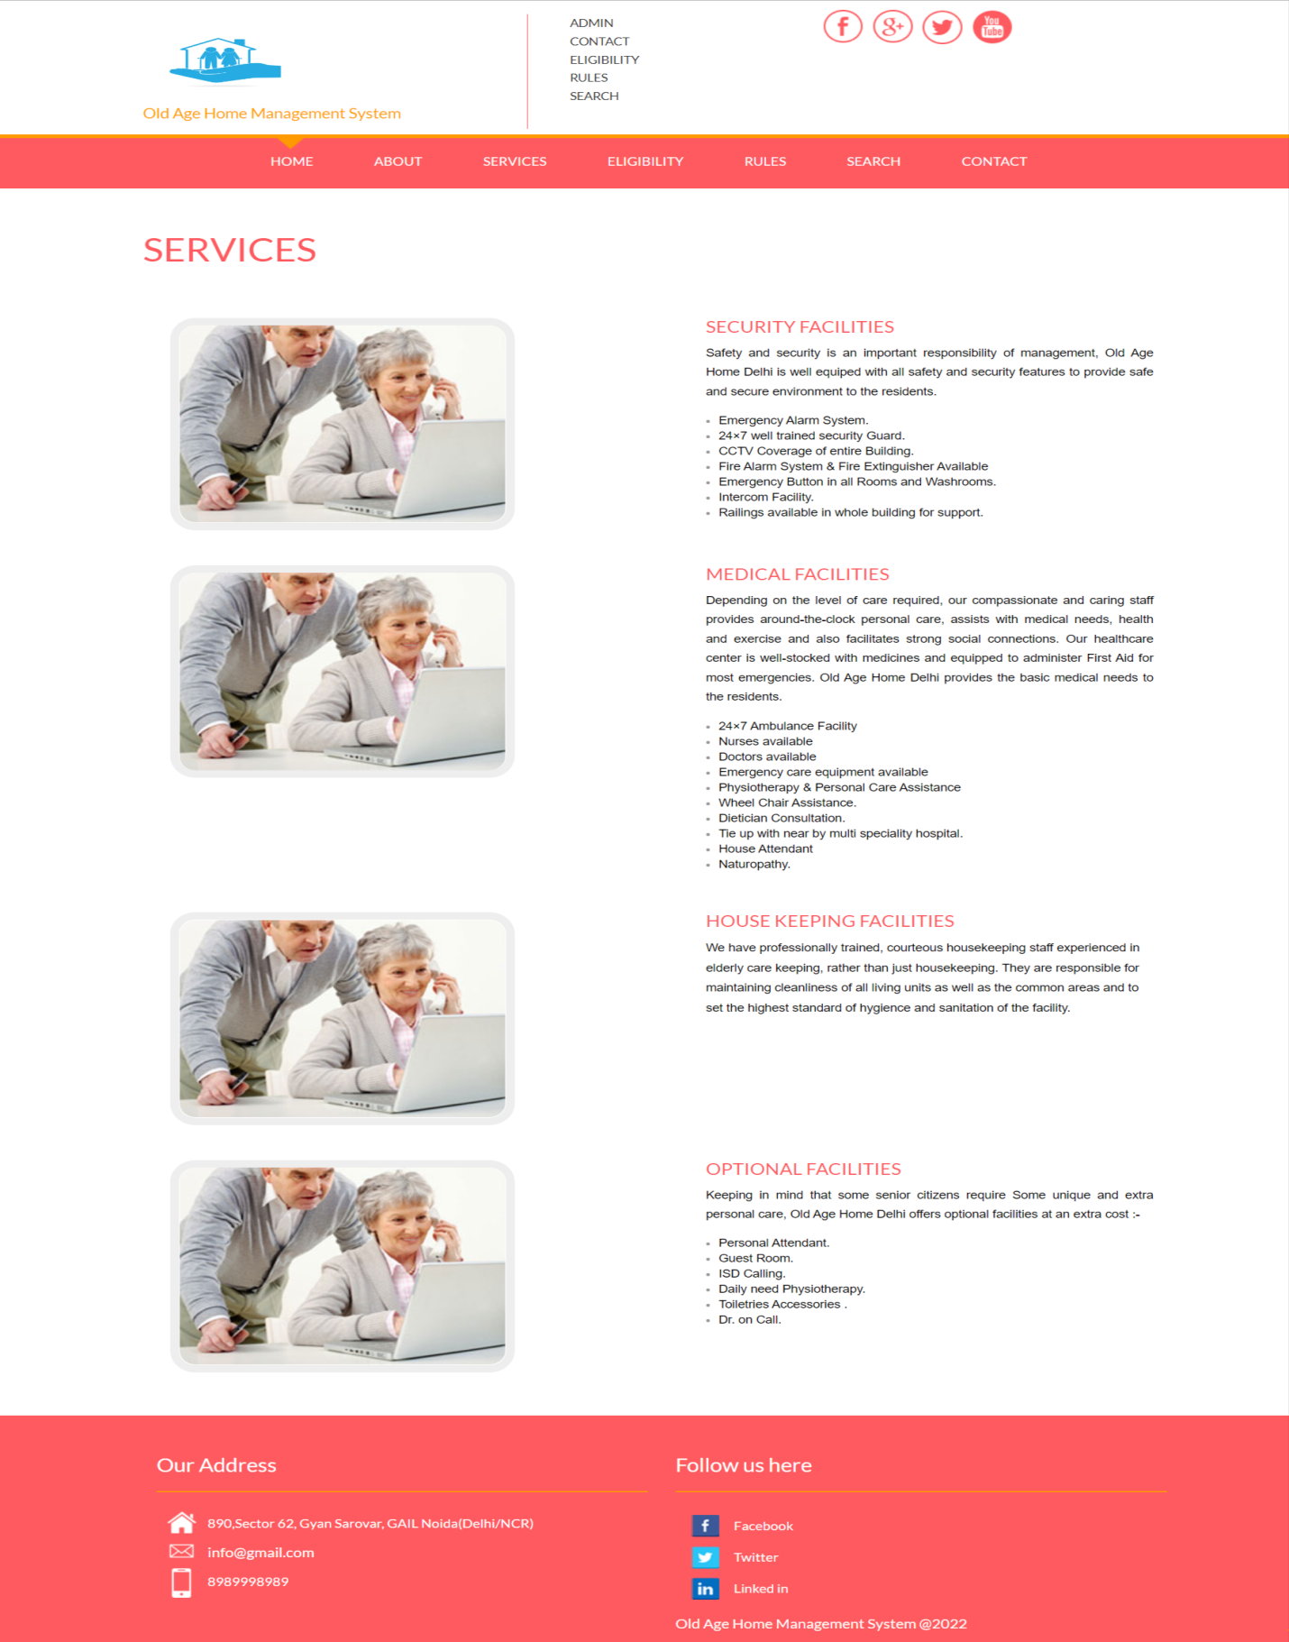

**Eligibility**

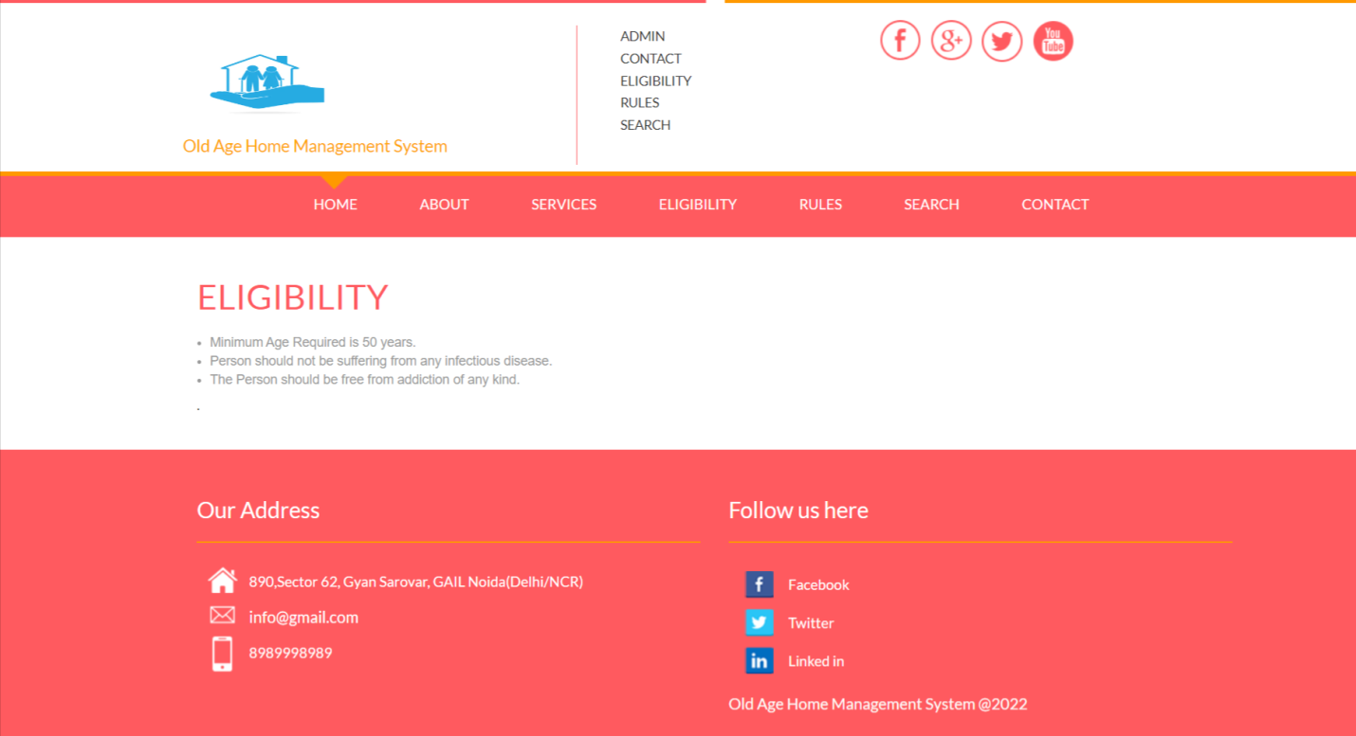

**Rules**

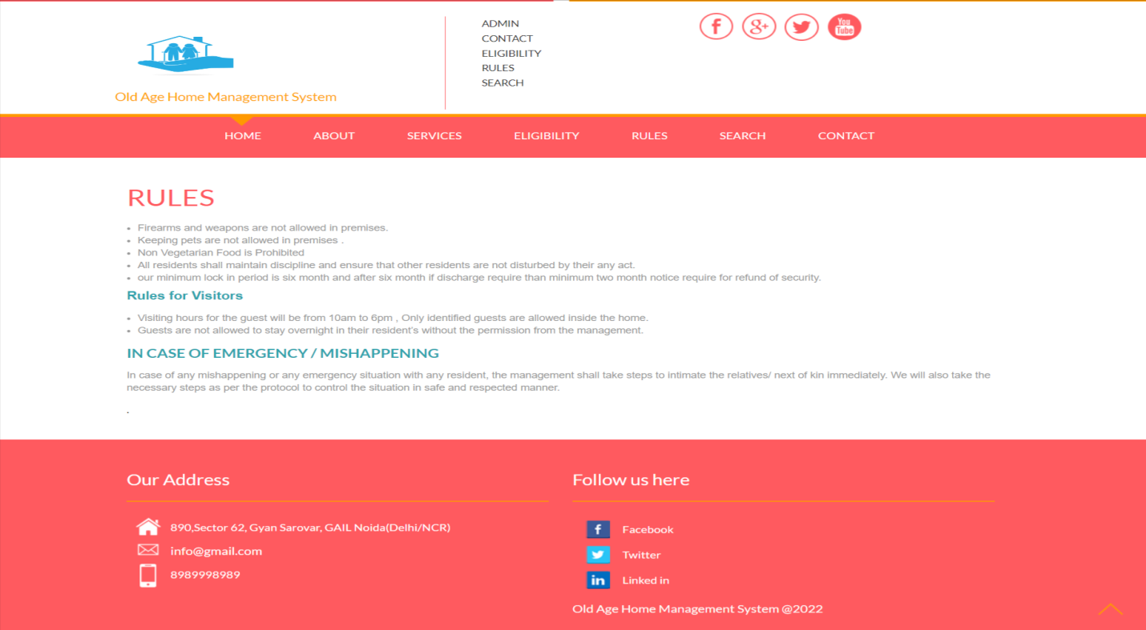

**Contact Us**

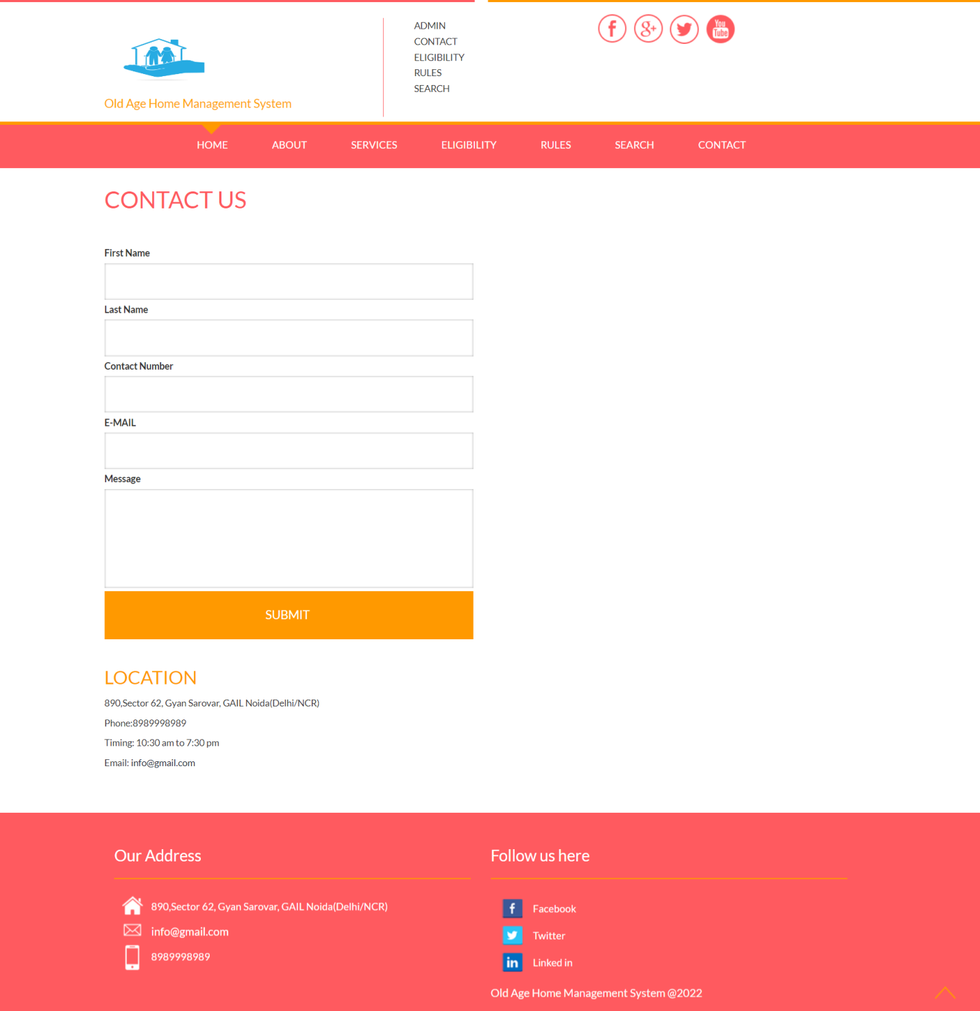

**Search**

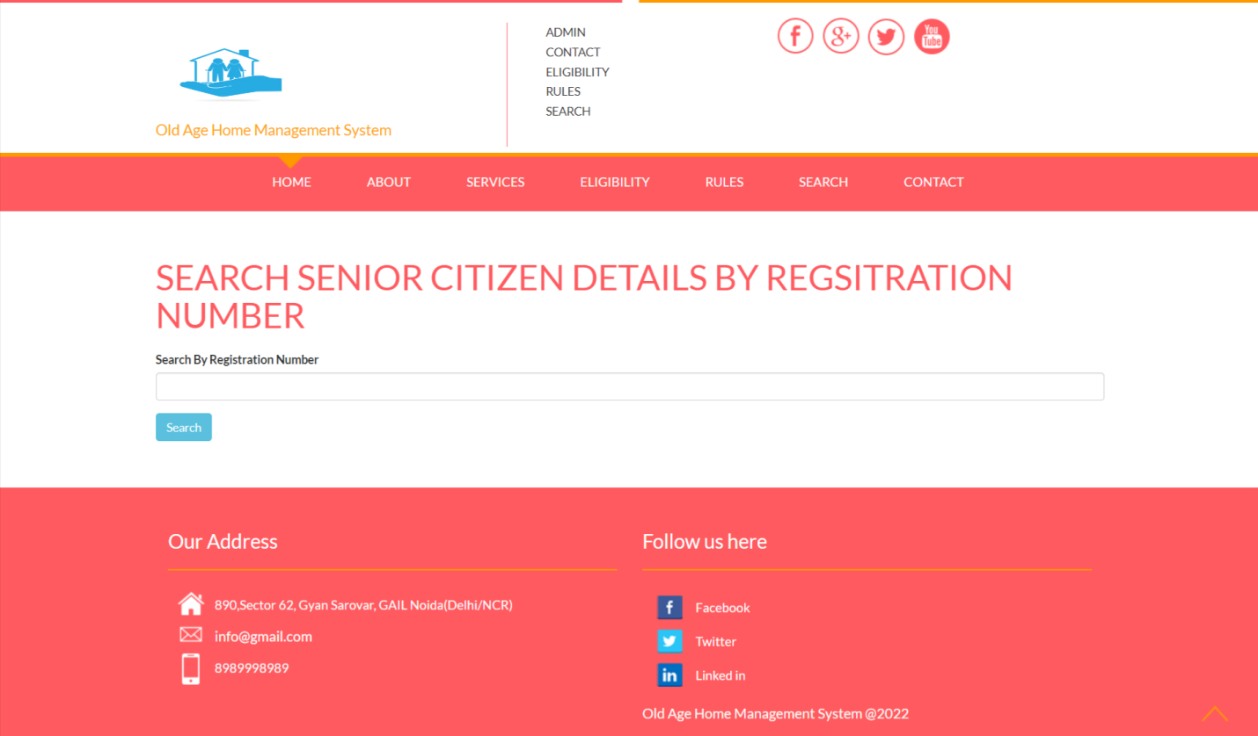

**ANNEXURE**

**5.1 Source code**

* **Index**

**<?php**

**include('includes/config.php');**

**session_start();**

**error_reporting(0);**

**?>**

**<!DOCTYPE HTML>**

**<html>**

**<head>**

**<title>Old Age Home Management System || Home Page</title>**

**<link href="css/bootstrap.css" rel='stylesheet' type='text/css' />**

**<!-- Custom Theme files -->**

**<link href="css/style.css" rel='stylesheet' type='text/css' />**

**<!--Custom Theme files-->**

**<script type="application/x-javascript"> addEventListener("load", function() { setTimeout(hideURLbar, 0); }, false); function hideURLbar(){ window.scrollTo(0,1); } </script>**

**</script>**

**<script src="js/jquery-1.8.3.min.js"></script>**

**<script src="js/modernizr.custom.js"></script>**

**<!--start-smoth-scrolling-->**

**<script type="text/javascript" src="js/move-top.js"></script>**

**<script type="text/javascript" src="js/easing.js"></script>**

**<script type="text/javascript">**

**jQuery(document).ready(function($) {**

**$(".scroll").click(function(event){**

**event.preventDefault();**

**$('html,body').animate({scrollTop:$(this.hash).offset().top},1000);**

**});**

**});**

**</script>**

**<!--start-smoth-scrolling-->**

**<!--webfonts-->**

**<link href='http://fonts.googleapis.com/css?family=Lato:100,300,400,700,900,300italic,400italic,700italic|Niconne' rel='stylesheet' type='text/css'>**

**<!--webfonts-->**

**</head>**

**<body>**

**<?php include_once('includes/header.php');?>**

**</div>**

**</div>**

**<div class="banner-section">**

**<div class="container">**

**<div class="banner-head">**

**<h1>Old age home is shelter place for senior citizen </h1>**

**<p>when an unknown printer took a galley of type and**

**scrambled it to make a type specimen book.**

**when an unknown printer took a galley of type and**

**scrambled it to make a type specimen book.**

**when an unknown printer took a galley of type and**

**scrambled it to make a type specimen book.</p>**

**</div>**

**</div>**

**</div>**

**<div class="welcome-section">**

**<div class="container">**

**<div class="welcom-grids">**

**<div class="col-md-6 welcom-grid-img">**

**<img src="images/v1.jpg" title="img" />**

**</div>**

**<div class="col-md-6 welcom-grid-text">**

**<?php**

**$ret=mysqli_query($con,"select * from tblpage where PageType='aboutus' ");**

**$cnt=1;**

**while ($row=mysqli_fetch_array($ret)) {**

**?>**

**<h2><?php echo $row['PageTitle'];?></h2>**

**<p><?php echo $row['PageDescription'];?>.</p><?php } ?>**

**</div>**

**<div class="clearfix"> </div>**

**</div>**

**</div>**

**</div>**

**<!--start-letest-->**

**<div class="letest-section">**

**<div class="container">**

**<?php**

**$ret=mysqli_query($con,"select * from tblpage where PageType='eligibility' ");**

**$cnt=1;**

**while ($row=mysqli_fetch_array($ret)) {**

**?>**

**<h3><?php echo $row['PageTitle'];?></h3>**

**<p><?php echo $row['PageDescription'];?>.</p><?php } ?>**

**<?php**

**$ret=mysqli_query($con,"select * from tblpage where PageType='rules' ");**

**$cnt=1;**

**while ($row=mysqli_fetch_array($ret)) {**

**?>**

**<h3><?php echo $row['PageTitle'];?></h3>**

**<p><?php echo $row['PageDescription'];?>.</p><?php } ?>**

**</div>**

**</div>**

**<!--/End-services-->**

**<div class="Events">**

**<div class="wmuSlider example1">**

**<div class="container">**

**<h3>Gallery</h3>**

**<article style="position: absolute; width:64%; opacity: 0;">**

**<div class="client-sections">**

**<div class="event-section">**

**<div class="col-md-4">**

**<div class="client-img">**

**<img src="images/c1.jpg" title="" />**

**</div>**

**</div>**

**<div class="col-md-4">**

**<div class="client-img">**

**<img src="images/c2.jpg" title="" />**

**</div>**

**</div>**

**<div class=" col-md-4">**

**<div class="client-img">**

**<img src="images/c3.jpg" title="" />**

**</div>**

**</div>**

**<div class="clearfix"> </div>**

**</div>**

**<div class="event-section1">**

**<div class="col-md-4">**

**<div class="client-img">**

**<img src="images/c4.jpg" title="" />**

**</div>**

**</div>**

**<div class="col-md-4">**

**<div class="client-img">**

**<img src="images/c5.jpg" title="" />**

**</div>**

**</div>**

**<div class=" col-md-4">**

**<div class="client-img">**

**<img src="images/c6.jpg" title="" />**

**</div>**

**</div>**

**</div>**

**<div class="clearfix"> </div>**

**</div>**

**</article>**

**<article style="position: absolute; width:64%; opacity: 0;">**

**<div class="client-sections">**

**<div class="event-section">**

**<div class="col-md-4">**

**<div class="client-img">**

**<img src="images/c6.jpg" title="" />**

**</div>**

**</div>**

**<div class="col-md-4">**

**<div class="client-img">**

**<img src="images/c5.jpg" title="" />**

**</div>**

**</div>**

**<div class=" col-md-4">**

**<div class="client-img">**

**<img src="images/c4.jpg" title="" />**

**</div>**

**</div>**

**<div class="clearfix"> </div>**

**</div>**

**<div class="event-section1">**

**<div class="col-md-4">**

**<div class="client-img">**

**<img src="images/c3.jpg" title="" />**

**</div>**

**</div>**

**<div class="col-md-4">**

**<div class="client-img">**

**<img src="images/c2.jpg" title="" />**

**</div>**

**</div>**

**<div class=" col-md-4">**

**<div class="client-img">**

**<img src="images/c1.jpg" title="" />**

**</div>**

**</div>**

**</div>**

**<div class="clearfix"> </div>**

**</div>**

**</article>**

**</div>**

**</div>**

**<div class="clearfix"> </div>**

**</div>**

**</div>**

**</div>**

**<script src="js/jquery.wmuSlider.js"></script>**

**<script>**

**$('.example1').wmuSlider();**

**</script>**

**<!--/new-projects-->**

**<!--/start-footer-->**

**<?php include_once('includes/footer.php');?>**

**<script type="text/javascript">**

**$(document).ready(function() {**

**/\***

**var defaults = {**

**containerID: 'toTop', // fading element id**

**containerHoverID: 'toTopHover', // fading element hover id**

**scrollSpeed: 1200,**

**easingType: 'linear'**

**};**

**\*/**

**$().UItoTop({ easingType: 'easeOutQuart' });**

**});**

**</script>**

**<a href="#home" id="toTop" class="scroll" style="display: block;"> <span id="toTopHover" style="opacity: 1;"> </span></a>**

**</body>**

**</html>**

* **About**

**<?php**

**include('includes/config.php');**

**session_start();**

**error_reporting(0);**

**?>**

**<!DOCTYPE HTML>**

**<html>**

**<head>**

**<title>Old Age Home Management System || About us Page</title>**

**<link href="css/bootstrap.css" rel='stylesheet' type='text/css' />**

**<!-- Custom Theme files -->**

**<link href="css/style.css" rel='stylesheet' type='text/css' />**

**<!--Custom Theme files-->**

**<script type="application/x-javascript"> addEventListener("load", function() { setTimeout(hideURLbar, 0); }, false); function hideURLbar(){ window.scrollTo(0,1); } </script>**

**</script>**

**<script src="js/jquery-1.8.3.min.js"></script>**

**<script src="js/modernizr.custom.js"></script>**

**<!--start-smoth-scrolling-->**

**<script type="text/javascript" src="js/move-top.js"></script>**

**<script type="text/javascript" src="js/easing.js"></script>**

**<script type="text/javascript">**

**jQuery(document).ready(function($) {**

**$(".scroll").click(function(event){**

**event.preventDefault();**

**$('html,body').animate({scrollTop:$(this.hash).offset().top},1000);**

**});**

**});**

**</script>**

**<!--start-smoth-scrolling-->**

**<!--webfonts-->**

**<link href='http://fonts.googleapis.com/css?family=Lato:100,300,400,700,900,300italic,400italic,700italic|Niconne' rel='stylesheet' type='text/css'>**

**<!--webfonts-->**

**</head>**

**<body>**

**<?php include_once('includes/header.php');?>**

**</div>**

**</div>**

**<!--start-about-->**

**<div class="About-section">**

**<div class="container">**

**<h3>ABOUT US</h3>**

**<div class="about-part">**

**<div class="about-pic">**

**<img class="img-responsive" src="images/about.jpg" alt="" />**

**</div>**

**<div class="about-textside">**

**<?php**

**$ret=mysqli_query($con,"select * from tblpage where PageType='aboutus' ");**

**$cnt=1;**

**while ($row=mysqli_fetch_array($ret)) {**

**?>**

**<p><?php echo $row['PageDescription'];?>.</p><?php } ?>**

**</div>**

**<div class="clearfix"> </div>**

**</div>**

**<!--Our-inspiration-->**

**<!--Our-inspiration-->**

**</div>**

**</div>**

**<?php include_once('includes/footer.php');?>**

**<script type="text/javascript">**

**$(document).ready(function() {**

**/\***

**var defaults = {**

**containerID: 'toTop', // fading element id**

**containerHoverID: 'toTopHover', // fading element hover id**

**scrollSpeed: 1200,**

**easingType: 'linear'**

**};**

**\*/**

**$().UItoTop({ easingType: 'easeOutQuart' });**

**});**

**</script>**

**<a href="#home" id="toTop" class="scroll" style="display: block;"> <span id="toTopHover" style="opacity: 1;"> </span></a>**

**</body>**

**</html>**

* **Contact**

**<?php**

**include('includes/config.php');**

**session_start();**

**error_reporting(0);**

**if(isset($_POST['submit']))**

**{**

**$fname=$_POST['fname'];**

**$lname=$_POST['lname'];**

**$phone=$_POST['phone'];**

**$email=$_POST['email'];**

**$message=$_POST['message'];**

**$query=mysqli_query($con, "insert into tblcontact(FirstName,LastName,Phone,Email,Message) value('$fname','$lname','$phone','$email','$message')");**

**if ($query) {**

**echo "<script>alert('Your message was sent successfully!.');</script>";**

**echo "<script>window.location.href ='contact.php'</script>";**

**}**

**else**

**{**

**echo '<script>alert("Something Went Wrong. Please try again")</script>';**

**}**

**}**

**?>**

**<!DOCTYPE HTML>**

**<html>**

**<head>**

**<title>Old Age Home Management System || Contact Us Page</title>**

**<link href="css/bootstrap.css" rel='stylesheet' type='text/css' />**

**<!-- Custom Theme files -->**

**<link href="css/style.css" rel='stylesheet' type='text/css' />**

**<!--Custom Theme files-->**

**<script type="application/x-javascript"> addEventListener("load", function() { setTimeout(hideURLbar, 0); }, false); function hideURLbar(){ window.scrollTo(0,1); } </script>**

**</script>**

**<script src="js/jquery-1.8.3.min.js"></script>**

**<script src="js/modernizr.custom.js"></script>**

**<!--start-smoth-scrolling-->**

**<script type="text/javascript" src="js/move-top.js"></script>**

**<script type="text/javascript" src="js/easing.js"></script>**

**<script type="text/javascript">**

**jQuery(document).ready(function($) {**

**$(".scroll").click(function(event){**

**event.preventDefault();**

**$('html,body').animate({scrollTop:$(this.hash).offset().top},1000);**

**});**

**});**

**</script>**

**<!--start-smoth-scrolling-->**

**<!--webfonts-->**

**<link href='http://fonts.googleapis.com/css?family=Lato:100,300,400,700,900,300italic,400italic,700italic|Niconne' rel='stylesheet' type='text/css'>**

**<!--webfonts-->**

**</head>**

**<body>**

**<!--header-->**

**<?php include_once('includes/header.php');?>**

**</div>**

**</div>**

**<!--start-content-->**

**<div class="contact_desc">**

**<div class="container">**

**<h2>Contact Us</h2>**

**<div class="contact-form">**

**<form method="post" class="left_form">**

**<div>**

**<span><label>First Name</label></span>**

**<span><input required="true" name="fname" type="text" class="textbox"></span>**

**</div>**

**<div>**

**<span><label>Last Name</label></span>**

**<span><input required="true" name="lname" type="text" class="textbox"></span>**

**</div>**

**<div>**

**<span><label>Contact Number</label></span>**

**<span><input required="true" name="phone" pattern="[0-9]+" maxlength="10" type="text" class="textbox"></span>**

**</div>**

**<div>**

**<span><label>E-MAIL</label></span>**

**<span><input required="" name="email" type="text" class="textbox"></span>**

**</div>**

**<div>**

**<span><label>Message</label></span>**

**<span><textarea required="true" name="message"> </textarea></span>**

**</div>**

**<div>**

**<input type="submit" value="Submit " name="submit" />**

**</div>**

**</form>**

**<div class="clearfix"></div>**

**</div>**

**<div class="content_bottompart">**

**<div class="company_address">**

**<?php**

**$ret=mysqli_query($con,"select * from tblpage where PageType='contactus' ");**

**$cnt=1;**

**while ($row=mysqli_fetch_array($ret)) {**

**?>**

**<h3>Location</h3>**

**<p><?php echo $row['PageDescription'];?></p>**

**<p>Phone:<?php echo $row['MobileNumber'];?></p>**

**<p>Timing: <?php echo $row['Timing'];?></p>**

**<p>Email: <span><a href="mailto:example@email.com"><?php echo $row['Email'];?></a></span></p><?php } ?>**

**</div>**

**<div class="clearfix"></div>**

**</div>**

**</div>**

**</div>**

**<!--/start-footer-->**

**<?php include_once('includes/footer.php');?>**

**<script type="text/javascript">**

**$(document).ready(function() {**

**/\***

**var defaults = {**

**containerID: 'toTop', // fading element id**

**containerHoverID: 'toTopHover', // fading element hover id**

**scrollSpeed: 1200,**

**easingType: 'linear'**

**};**

**\*/**

**$().UItoTop({ easingType: 'easeOutQuart' });**

**});**

**</script>**

**<a href="#home" id="toTop" class="scroll" style="display: block;"> <span id="toTopHover" style="opacity: 1;"> </span></a>**

**</body>**

**</html>**

* **Eligibility**

**<?php**

**include('includes/config.php');**

**session_start();**

**error_reporting(0);**

**?>**

**<!DOCTYPE HTML>**

**<html>**

**<head>**

**<title>Old Age Home Management System || Eligibility Page</title>**

**<link href="css/bootstrap.css" rel='stylesheet' type='text/css' />**

**<!-- Custom Theme files -->**

**<link href="css/style.css" rel='stylesheet' type='text/css' />**

**<link rel="stylesheet" type="text/css" href="css/component.css" />**

**<script type="application/x-javascript"> addEventListener("load", function() { setTimeout(hideURLbar, 0); }, false); function hideURLbar(){ window.scrollTo(0,1); } </script>**

**</script>**

**<script src="js/jquery-1.8.3.min.js"></script>**

**<script src="js/modernizr.custom.js"></script>**

**<!--start-smoth-scrolling-->**

**<script type="text/javascript" src="js/move-top.js"></script>**

**<script type="text/javascript" src="js/easing.js"></script>**

**<script type="text/javascript">**

**jQuery(document).ready(function($) {**

**$(".scroll").click(function(event){**

**event.preventDefault();**

**$('html,body').animate({scrollTop:$(this.hash).offset().top},1000);**

**});**

**});**

**</script>**

**<!--start-smoth-scrolling-->**

**<!--webfonts-->**

**<link href='http://fonts.googleapis.com/css?family=Lato:100,300,400,700,900,300italic,400italic,700italic|Niconne' rel='stylesheet' type='text/css'>**

**<!--webfonts-->**

**</head>**

**<body>**

**<?php include_once('includes/header.php');?>**

**</div>**

**</div>**

**<div class="gallery-section">**

**<div class="container">**

**<div class="letest-section">**

**<div class="container">**

**<?php**

**$ret=mysqli_query($con,"select * from tblpage where PageType='eligibility' ");**

**$cnt=1;**

**while ($row=mysqli_fetch_array($ret)) {**

**?>**

**<h3><?php echo $row['PageTitle'];?></h3>**

**<p><?php echo $row['PageDescription'];?>.</p><?php } ?>**

**</div>**

**</div>**

**</div>**

**</div>**

**<!-- /main -->**

**<script src="js/classie.js"></script>**

**<script src="js/cbpViewModeSwitch.js"></script>**

**<!--/start-footer-->**

**<?php include_once('includes/footer.php');?>**

**<script type="text/javascript">**

**$(document).ready(function() {**

**/\***

**var defaults = {**

**containerID: 'toTop', // fading element id**

**containerHoverID: 'toTopHover', // fading element hover id**

**scrollSpeed: 1200,**

**easingType: 'linear'**

**};**

**\*/**

**$().UItoTop({ easingType: 'easeOutQuart' });**

**});**

**</script>**

**<a href="#home" id="toTop" class="scroll" style="display: block;"> <span id="toTopHover" style="opacity: 1;"> </span></a>**

**</body>**

**</html>**

* **Rules**

**<?php**

**include('includes/config.php');**

**session_start();**

**error_reporting(0);**

**?>**

**<!DOCTYPE HTML>**

**<html>**

**<head>**

**<title>Old Age Home Management System || Eligibility Page</title>**

**<link href="css/bootstrap.css" rel='stylesheet' type='text/css' />**

**<!-- Custom Theme files -->**

**<link href="css/style.css" rel='stylesheet' type='text/css' />**

**<link rel="stylesheet" type="text/css" href="css/component.css" />**

**<script type="application/x-javascript"> addEventListener("load", function() { setTimeout(hideURLbar, 0); }, false); function hideURLbar(){ window.scrollTo(0,1); } </script>**

**</script>**

**<script src="js/jquery-1.8.3.min.js"></script>**

**<script src="js/modernizr.custom.js"></script>**

**<!--start-smoth-scrolling-->**

**<script type="text/javascript" src="js/move-top.js"></script>**

**<script type="text/javascript" src="js/easing.js"></script>**

**<script type="text/javascript">**

**jQuery(document).ready(function($) {**

**$(".scroll").click(function(event){**

**event.preventDefault();**

**$('html,body').animate({scrollTop:$(this.hash).offset().top},1000);**

**});**

**});**

**</script>**

**<!--start-smoth-scrolling-->**

**<!--webfonts-->**

**<link href='http://fonts.googleapis.com/css?family=Lato:100,300,400,700,900,300italic,400italic,700italic|Niconne' rel='stylesheet' type='text/css'>**

**<!--webfonts-->**

**</head>**

**<body>**

**<?php include_once('includes/header.php');?>**

**</div>**

**</div>**

**<div class="gallery-section">**

**<div class="container">**

**<div class="letest-section">**

**<div class="container">**

**<?php**

**$ret=mysqli_query($con,"select * from tblpage where PageType='rules' ");**

**$cnt=1;**

**while ($row=mysqli_fetch_array($ret)) {**

**?>**

**<h3><?php echo $row['PageTitle'];?></h3>**

**<p><?php echo $row['PageDescription'];?>.</p><?php } ?>**

**</div>**

**</div>**

**</div>**

**</div>**

**<!-- /main -->**

**<script src="js/classie.js"></script>**

**<script src="js/cbpViewModeSwitch.js"></script>**

**<!--/start-footer-->**

**<?php include_once('includes/footer.php');?>**

**<script type="text/javascript">**

**$(document).ready(function() {**

**/\***

**var defaults = {**

**containerID: 'toTop', // fading element id**

**containerHoverID: 'toTopHover', // fading element hover id**

**scrollSpeed: 1200,**

**easingType: 'linear'**

**};**

**\*/**

**$().UItoTop({ easingType: 'easeOutQuart' });**

**});**

**</script>**

**<a href="#home" id="toTop" class="scroll" style="display: block;"> <span id="toTopHover" style="opacity: 1;"> </span></a>**

**</body>**

**</html>**

**Search**

**<?php**

**include('includes/config.php');**

**session_start();**

**error_reporting(0);**

**?>**

**<!DOCTYPE HTML>**

**<html>**

**<head>**

**<title>Old Age Home Management System || Search</title>**

**<link href="css/bootstrap.css" rel='stylesheet' type='text/css' />**

**<!-- Custom Theme files -->**

**<link href="css/style.css" rel='stylesheet' type='text/css' />**

**<!--Custom Theme files-->**

**<script type="application/x-javascript"> addEventListener("load", function() { setTimeout(hideURLbar, 0); }, false); function hideURLbar(){ window.scrollTo(0,1); } </script>**

**</script>**

**<script src="js/jquery-1.8.3.min.js"></script>**

**<script src="js/modernizr.custom.js"></script>**

**<!--start-smoth-scrolling-->**

**<script type="text/javascript" src="js/move-top.js"></script>**

**<script type="text/javascript" src="js/easing.js"></script>**

**<script type="text/javascript">**

**jQuery(document).ready(function($) {**

**$(".scroll").click(function(event){**

**event.preventDefault();**

**$('html,body').animate({scrollTop:$(this.hash).offset().top},1000);**

**});**

**});**

**</script>**

**<!--start-smoth-scrolling-->**

**<!--webfonts-->**

**<link href='http://fonts.googleapis.com/css?family=Lato:100,300,400,700,900,300italic,400italic,700italic|Niconne' rel='stylesheet' type='text/css'>**

**<!--webfonts-->**

**</head>**

**<body>**

**<?php include_once('includes/header.php');?>**

**</div>**

**<!--/start-footer-->**

**<!--content-->**

**<div class="content">**

**<div class="blog">**

**<div class="container">**

**<div class="blog-top">**

**<h3>Search Senior Citizen details by regsitration number</h3>**

**<div class="content-wrapper">**

**<div class="row">**

**<div class="col-md-12 grid-margin stretch-card">**

**<div class="card">**

**<div class="card-body">**

**<form class="forms-sample" method="post">**

**<div class="form-group">**

**<label for="exampleInputUsername1">Search By Registration Number</label>**

**<input type="text" id="searchdata" name="searchdata" class="form-control" required="required" autofocus="autofocus" >**

**</div>**

**<button type="submit" name="search" class="btn btn-info btn-min-width mr-1 mb-1">Search</button>**

**</form>**

**</div>**

**</div>**

**</div>**

**</div>**

**</div>**

**</div>**

**<div class="table-responsive pt-3">**

**<?php**

**if(isset($_POST['search']))**

**{**

**$sdata=$_POST['searchdata'];**

**?>**

**<h4 class="card-title" style="padding-left: 20px; padding-top: 20px;">Result against "<?php echo $sdata;?>" keyword</h4>**

**<table class="table table-striped project-orders-table">**

**<thead>**

**<tr>**

**<th class="ml-5">#</th>**

**<th>Registration Number</th>**

**<th>Name</th>**

**<th>Contact Number</th>**

**<th>Date of Birth</th>**

**<th>Added By</th>**

**<th>Registration Date</th>**

**<th>Actions</th>**

**</tr>**

**</thead>**

**<tbody>**

**<?php**

**$query=mysqli_query($con,"select * from tblseniorcitizen where tblseniorcitizen.RegistrationNumber like '$sdata%'");**

**$num=mysqli_num_rows($query);**

**if($num>0){**

**$cnt=1;**

**while($row=mysqli_fetch_array($query))**

**{**

**?>**

**<tr>**

**<td><?php echo htmlentities($cnt);?></td>**

**<td><?php echo htmlentities($row['RegistrationNumber']);?> </td>**

**<td><?php echo htmlentities($row['Name']);?> </td>**

**<td><?php echo htmlentities($row['ContactNumber']);?> </td>**

**<td><?php echo htmlentities($row['DateofBirth']);?> </td>**

**<td><?php echo htmlentities($row['AddedBy']);?> </td>**

**<td><?php echo htmlentities($row['RegitrationDate']);?></td>**

**<td>**

**<div class="d-flex align-items-center">**

**<a href="view-scdetails.php?id=<?php echo $row['ID']?>" class="btn btn-success btn-sm btn-icon-text mr-3">View <i class="typcn typcn-edit btn-icon-append"></i> </a>**

**</div>**

**</td>**

**</tr> <?php**

**$cnt=$cnt+1;**

**} } else { ?>**

**<tr>**

**<td colspan="8"> No record found against this search</td>**

**</tr>**

**<?php } }?>**

**</tbody>**

**</table>**

**</div>**

**</div>**

**</div>**

**<?php include_once('includes/footer.php');?>**

**<script type="text/javascript">**

**$(document).ready(function() {**

**/\***

**var defaults = {**

**containerID: 'toTop', // fading element id**

**containerHoverID: 'toTopHover', // fading element hover id**

**scrollSpeed: 1200,**

**easingType: 'linear'**

**};**

**\*/**

**$().UItoTop({ easingType: 'easeOutQuart' });**

**});**

**</script>**

**<a href="#home" id="toTop" class="scroll" style="display: block;"> <span id="toTopHover" style="opacity: 1;"> </span></a>**

**</body>**

**</html>**

**Services**

**<?php**

**include('includes/config.php');**

**session_start();**

**error_reporting(0);**

**?>**

**<!DOCTYPE HTML>**

**<html>**

**<head>**

**<title>Old Age Home Management System || Search</title>**

**<link href="css/bootstrap.css" rel='stylesheet' type='text/css' />**

**<!-- Custom Theme files -->**

**<link href="css/style.css" rel='stylesheet' type='text/css' />**

**<!--Custom Theme files-->**

**<script type="application/x-javascript"> addEventListener("load", function() { setTimeout(hideURLbar, 0); }, false); function hideURLbar(){ window.scrollTo(0,1); } </script>**

**</script>**

**<script src="js/jquery-1.8.3.min.js"></script>**

**<script src="js/modernizr.custom.js"></script>**

**<!--start-smoth-scrolling-->**

**<script type="text/javascript" src="js/move-top.js"></script>**

**<script type="text/javascript" src="js/easing.js"></script>**

**<script type="text/javascript">**

**jQuery(document).ready(function($) {**

**$(".scroll").click(function(event){**

**event.preventDefault();**

**$('html,body').animate({scrollTop:$(this.hash).offset().top},1000);**

**});**

**});**

**</script>**

**<!--start-smoth-scrolling-->**

* **View Schedules**

**<?php**

**include('includes/config.php');**

**session_start();**

**error_reporting(0);**

**?>**

**<!DOCTYPE HTML>**

**<html>**

**<head>**

**<title>Old Age Home Management System || Search</title>**

**<link href="css/bootstrap.css" rel='stylesheet' type='text/css' />**

**<!-- Custom Theme files -->**

**<link href="css/style.css" rel='stylesheet' type='text/css' />**

**<!--Custom Theme files-->**

**<script type="application/x-javascript"> addEventListener("load", function() { setTimeout(hideURLbar, 0); }, false); function hideURLbar(){ window.scrollTo(0,1); } </script>**

**</script>**

**<script src="js/jquery-1.8.3.min.js"></script>**

**<script src="js/modernizr.custom.js"></script>**

**<!--start-smoth-scrolling-->**

**<script type="text/javascript" src="js/move-top.js"></script>**

**<script type="text/javascript" src="js/easing.js"></script>**

**<script type="text/javascript">**

**jQuery(document).ready(function($) {**

**$(".scroll").click(function(event){**

**event.preventDefault();**

**$('html,body').animate({scrollTop:$(this.hash).offset().top},1000);**

**});**

**});**

**</script>**

**<!--start-smoth-scrolling-->**

**<!--webfonts-->**

**<link href='http://fonts.googleapis.com/css?family=Lato:100,300,400,700,900,300italic,400italic,700italic|Niconne' rel='stylesheet' type='text/css'>**

**<!--webfonts-->**

**</head>**

**<body>**

**<?php include_once('includes/header.php');?>**

**</div>**

**<!--/start-footer-->**

**<!--content-->**

**<div class="content">**

**<div class="blog">**

**<div class="container">**

**<?php**

**$id=intval($_GET['id']);**

**$query=mysqli_query($con,"select * from tblseniorcitizen where tblseniorcitizen.ID='$id'");**

**while($row=mysqli_fetch_array($query))**

**{**

**?>**

**<div class="blog-top">**

**<h3>View Detail of <?php echo htmlentities($row['Name']);?></h3>**

**</div>**

**<div class="blog-bottom">**

**<div class=" single-top">**

**<div class="left-blog">**

**<a href="single.html"><img class="img-responsive" src="admin/images/<?php echo htmlentities($row['ProfilePic']);?>" width="300" height="300" alt="" /></a>**

**</div>**

**<div class="top-blog">**

**<a class="fast" href="#"><h2>Date of Registration: <?php echo htmlentities($row['RegitrationDate']);?> </h2></a>**

**<ul class="men-grid">**

**<li><strong>Added By: </strong><?php echo htmlentities($row['AddedBy']);?><strong>, </li>**

**<li>Registration Number: </strong><?php echo htmlentities($row['RegistrationNumber']);?></li>**

**</ul>**

**<p><strong>Date of Birth:</strong><?php echo htmlentities($row['DateofBirth']);?></p>**

**<p><strong>Contact Number: </strong><?php echo htmlentities($row['ContactNumber']);?></p>**

**<p><strong>Communication Address: </strong><?php echo htmlentities($row['CommunicationAddress']);?></p>**

**<p><strong>Emergency Address: </strong><?php echo htmlentities($row['EmergencyAddress']);?>.</p>**

**<p><strong>Emergency Contact Number: </strong><?php echo htmlentities($row['EmergencyContactnumber']);?>.</p>**

**</div>**

**<div class="clearfix"> </div>**

**</div><?php } ?>**

**</div>**

**</div>**

**</div>**

**<?php include_once('includes/footer.php');?>**

**<script type="text/javascript">**

**$(document).ready(function() {**

**/\***

**var defaults = {**

**containerID: 'toTop', // fading element id**

**containerHoverID: 'toTopHover', // fading element hover id**

**scrollSpeed: 1200,**

**easingType: 'linear'**

**};**

**\*/**

**$().UItoTop({ easingType: 'easeOutQuart' });**

**});**

**</script>**

**<a href="#home" id="toTop" class="scroll" style="display: block;"> <span id="toTopHover" style="opacity: 1;"> </span></a>**

**</body>**

**</html>**

**Conclusion And Suggestion**

**6.1 Limitations**

* This system is completely online so the user must have an active internet connection.
* This system does not have any biometric scan to identify if the documents submitted by the person are genuine or not.
* This system does not have any agreement form or admission form so it has to be done manually.
* This system is online so in case of a bad weather it will not work properly.
* If some rules are being changed so only the admin can change the details of the respective page.
* Users can only interact with the system through the contact page leaving their feedback so the users have to wait until admin reads their enquiry and sends a response.
* This system is limited for a small scale Old Age Home which has a limited numbers of rules and services available.
* This system does not provide a user sign in or log in option making it less user interactive.
* This system is completely developed for administrative end so any changes in the details of the citizens are done by admin only.

**6.2 Further Enhancement**

In the present system all the work is done on the paper. The whole details are stored in the registers. We can’t generate reports as per our requirements because it takes more time to make reports of the senior citizens. To tackle this problem the “Old Age Home Management System” is developed.

**Problems in present system:**

* Not user friendly
* Manual Control
* Lots of paper work
* Time Consuming

This system solves all the problems that are present in the current system. Since this system is completely online it makes it user friendly. There is no need to do any paper work because the data is stored in the database. This system is time saving also reduces human efforts to some extent.

This system has an attractive design which makes it user friendly also it has an enquiry system in case any user want to send an enquiry. The enquiries can be read by the admin and will be responded accordingly. This system also provides a searching option. User can search the senior citizen’s details by entering the registration number.

**6.3 Conclusion**

The application was designed in such a way that future modifications can be done easily. The following conclusion can be deduced from the development of the project.

* Automation of the entire system improves the efficiency.
* It provides a friendly graphical user interface which proves to be better when compared to the existing system.
* It gives appropriate access to the authorized users depending on their permissions.
* It effectively overcomes the delay in communications.
* Updating of information becomes so easier.
* System security, data security and reliability are the striking features.
* The System has adequate scope for modification in future if it is necessary.
* Managing the details of the senior citizen becomes easier as compared to the manual system.
* Any old age home looking for digitalizing itself can go for this system.
* This system handles and manages the data very efficiently.

**REFERENCES**

* www.w3schools.com
* ***php****.net*
* *en.wikipedia.org/wiki/****PHP***
* www.hotscripts.com/category/**php**/
* www.**apache**.org
* www.**mysql**.com